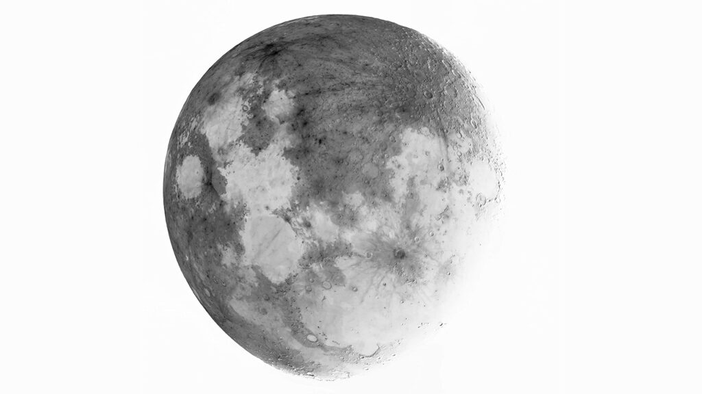

The Hidden Wilderness and the Moon Map

by Noel Joshua Hadley
11/2/2022

STARTING out on page one of this discussion I slipped in a picture of the moon wondering which of my readers had already done their homework and knew precisely where this is all headed. The hidden wilderness very likely can be found on a map. A very old map for sure. I guess you could even say an outdated map, seeing as how Atlantis and other landmarks are still present and accounted for. But a map none-the-less. I’m showing it again so as to refresh your memory. The map of our greater realm in case you haven’t caught on yet is the moon.
I was fortunate enough to learn the trade of photography in an actual dark room before this present digital revolution, and therefore know precisely what’s going on here. You are looking at a negative image of the moon. If you did happen to miss out on the Nineties or any decade prior and can’t recall the excitement of picking up your envelopes of 24 to 36 Kodak photos at the local shopping malls one-hour development lab, not knowing which were of last year’s family vacation or of grandma blowing out her birthday candles, then allow me to explain.
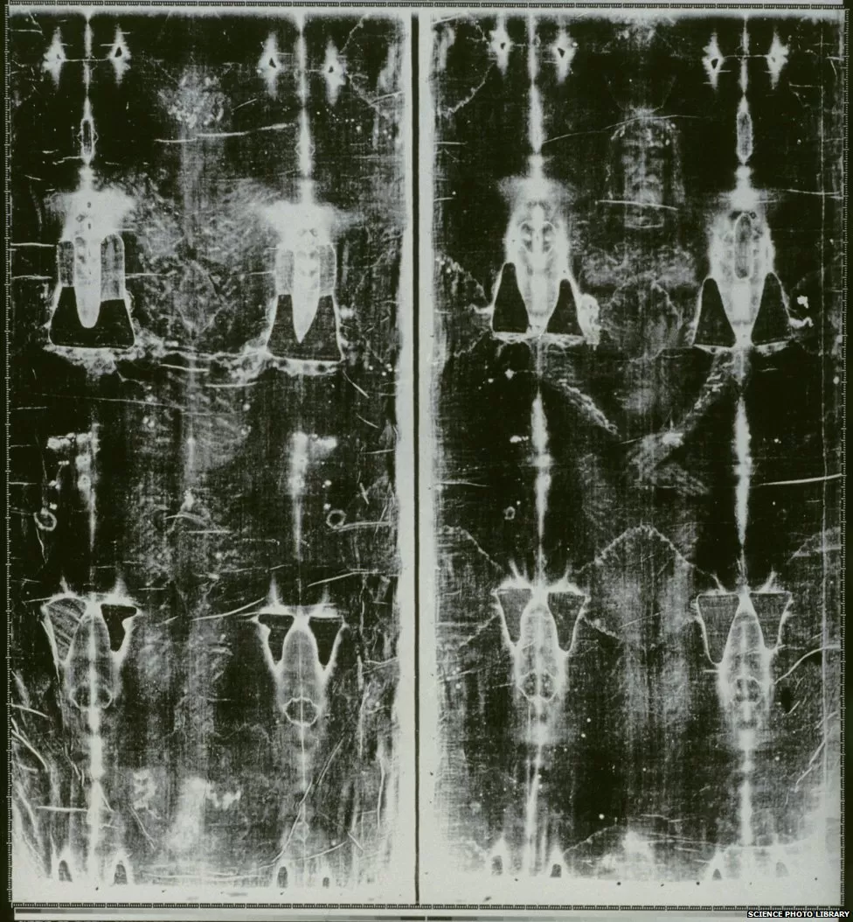
In photography, negatives are the images imprinted on long plastic strips. They’re the actual rolls of film that are unwound from the film canister after having been loaded within the belly of the camera. Each negative is transparent. You have to hold them up to the light in order to see the image within, but everything is reversed. The lightest areas appear darkest, whereas the darkest areas appear lightest. If you are a white person, then your skin would be black and the pupils of your eyes white. This reversed order occurs because the extremely light-sensitive chemicals a camera film must use to capture an image quickly enough are darkened, rather than bleached, by exposure to various degrees of light. In the case of color negatives, the colors are also reversed into their respective complementary colors.
The irony here is that the negative I showed you regarding the moon isn’t its true negative. No, it should be the positive. The light areas of the quote-unquote “negative” denote land whereas the dark areas constitute water. Contrarily, what you are staring at in any given night sky is its negative. Do you know what else can only be viewed as a negative image? I have already given away the answer. The Shroud of Turin is a negative. One must wonder if they were created in a similar fashion.
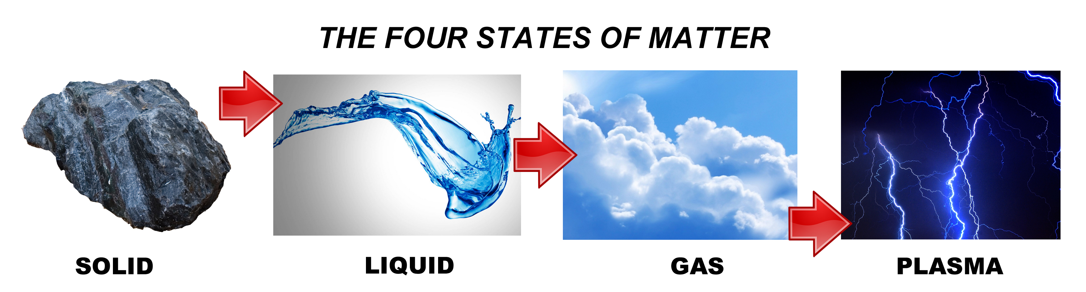
None of this will make any sense if you’re still hung up on the moon being a hunk of rock held in place by a gravitational pull in an ever-expanding vacuum of space, complete with an American flag and Neil Armstrong’s boot print, LOL. The moon is a focused electromagnetic phenomenon called plasma. Another way of stating the obvious is that we live in an electrical realm. Cosmic electromagnetic energy is passed back and forth between the flat motionless plane below and the firmament above, via the Aether. The inner reflection of this electromagnetic energy on our ceiling turns it back down, creating a focus spot point. At this spot, there is an observable fluorescence of the Aether because of the focused cosmic electromagnetic energy. The spot that is created is the moon.
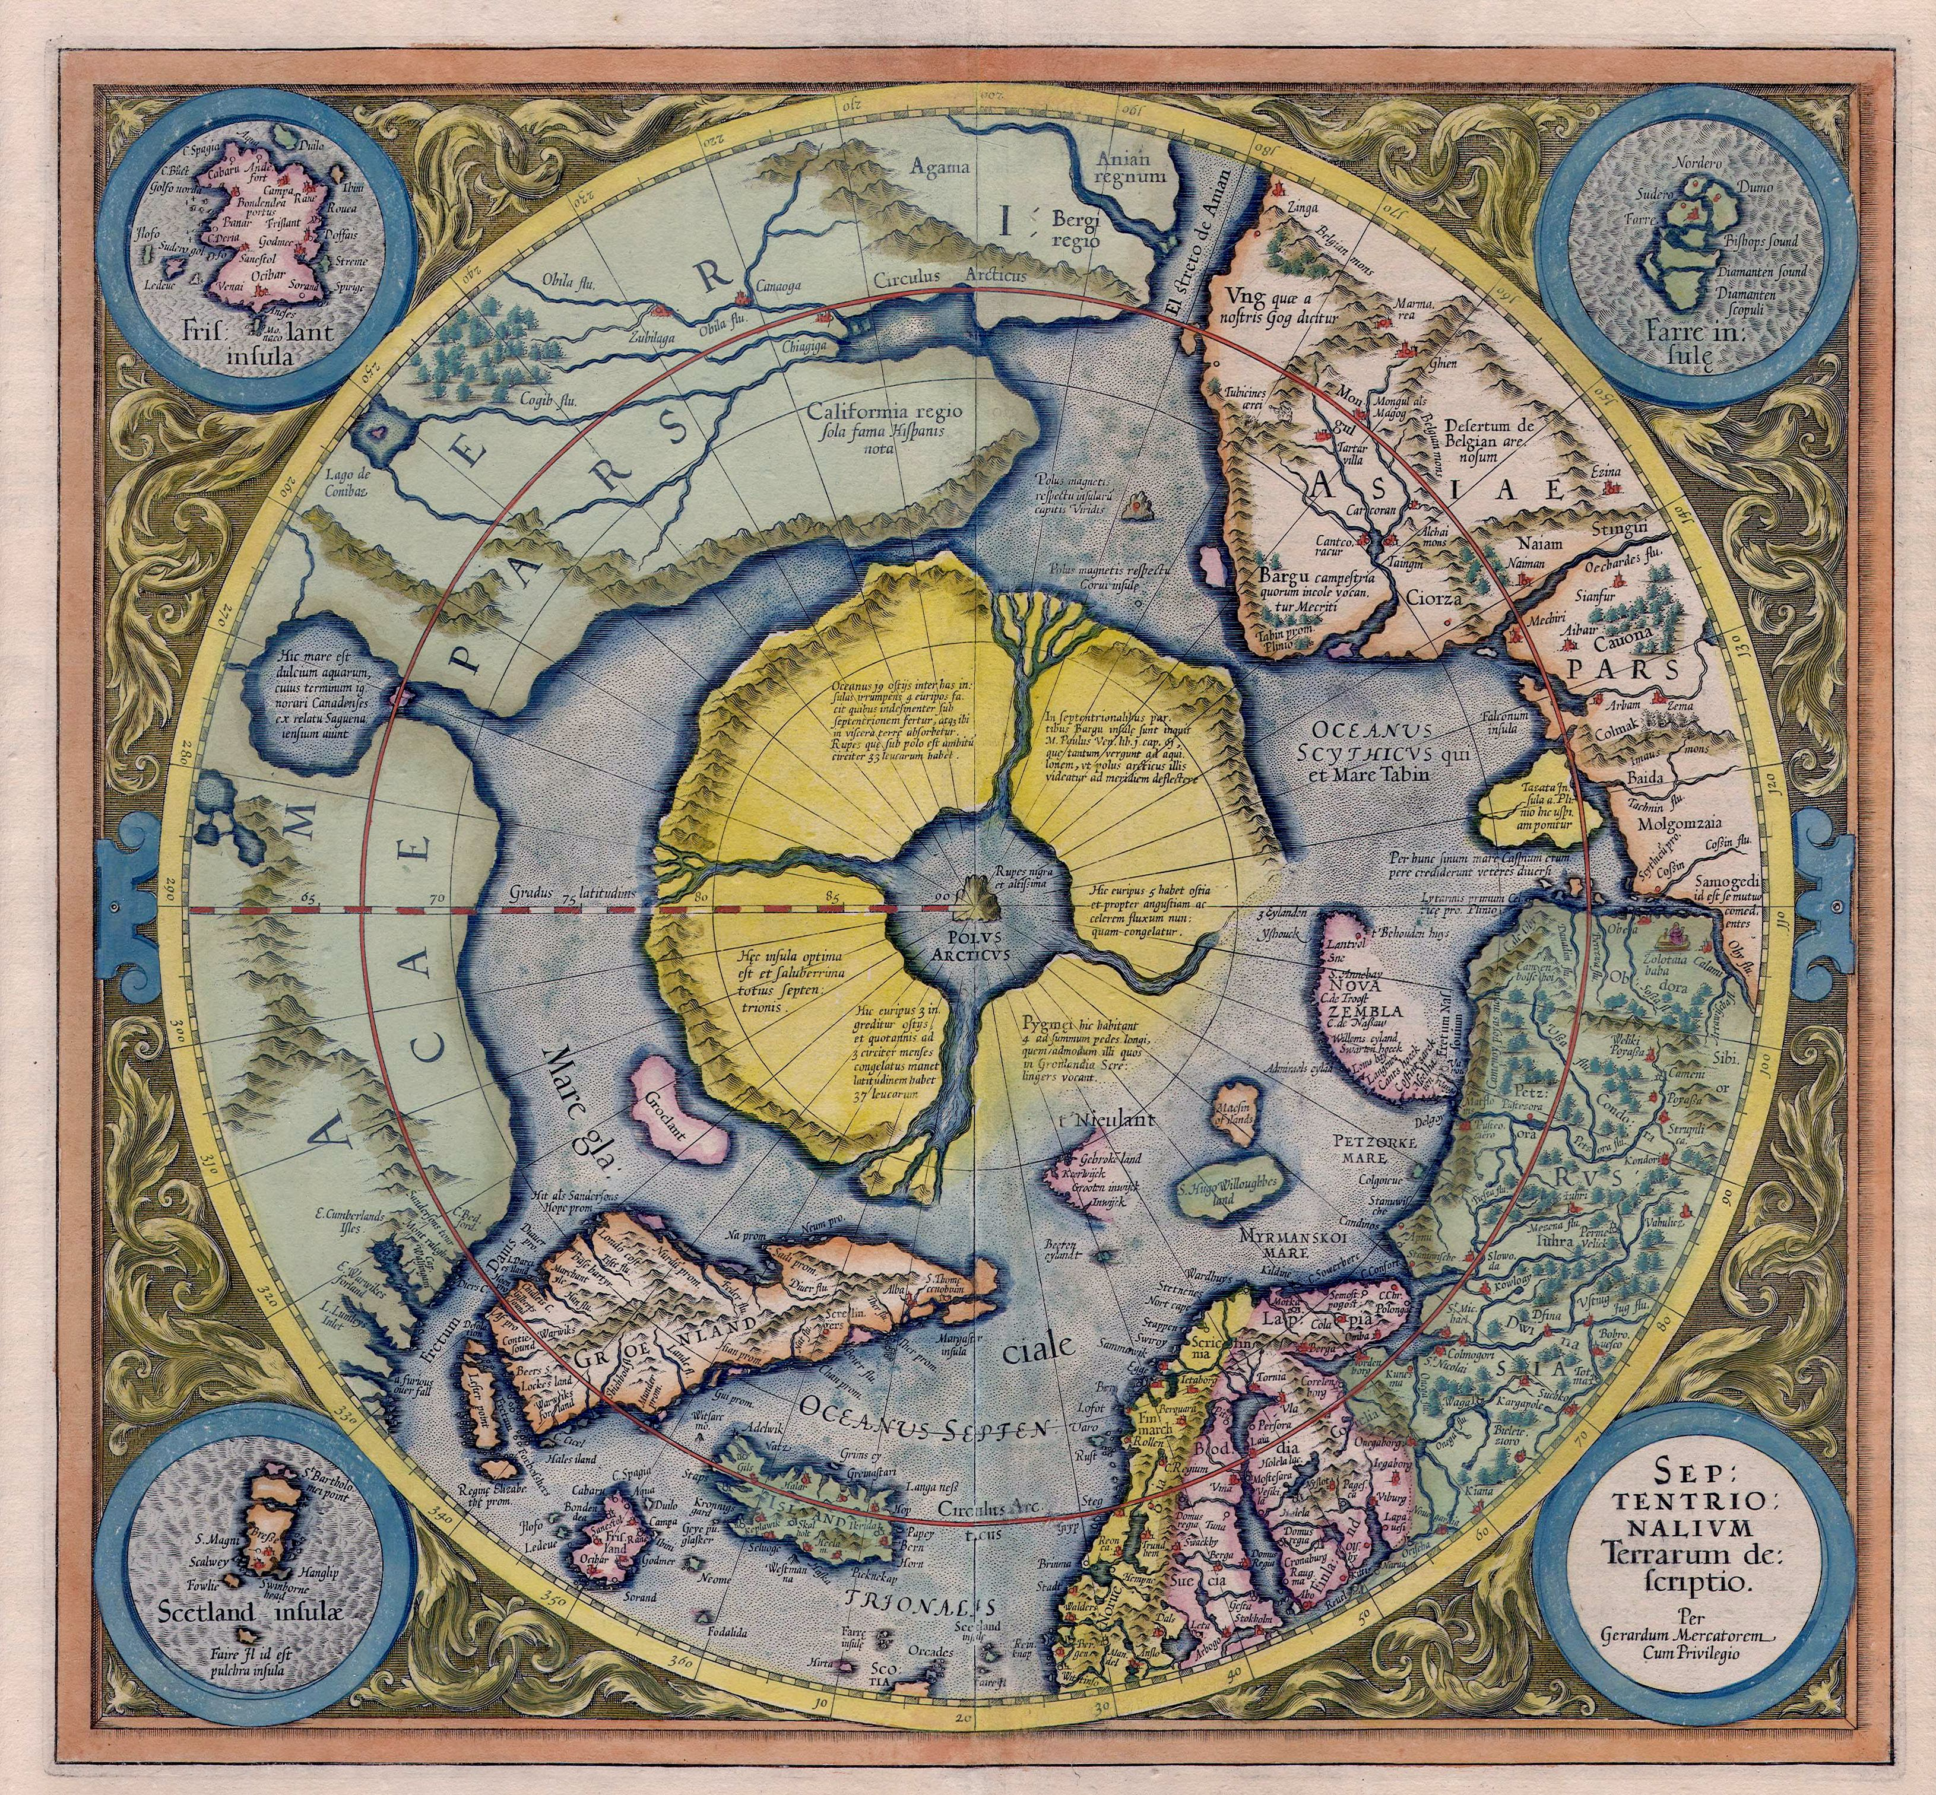
That was wordy, wasn’t it? Good roadside directions are hard to come by. Let’s see if I can break this down in simpler language. Starting again. To better understand the moon, we likely need to venture back to our magnetic north. Hyperborea. It is there where we can expect to find a magnetic rock, the heart’s desire of our every compass. The ancients spoke of a whirlpool. Let’s go with that and assume it is the location of the abyss. In the abyss we shouldn’t be surprised to discover a magnetic coil. Seems logical. Really, it’s not like we’re talking about some decorative barbershop pole on a floating iceberg. Any form of intense electromagnetism would naturally produce strong radiation. It is quite possible that our plasma moon is the result of that radiation but in the form of an x-ray.
X-rays are a penetrating form of high-energy electromagnetic radiation. Like so many other advances in modern Science, x-radiation was “discovered” in the post mud flood era by our Controllers. 1895 to be exact. In this scenario however the x-ray is emanating from a vortex in the center of our realm, rising upwards towards the Aether in divergent though invisible lines. Those beams continue until coming into contact with the firmament itself.
The beams of an x-ray differ from light beams in that they do not reflect off mirrors the same way that visible light does. Because of their high-energy, X-ray photons that strike a mirror directly will penetrate into the mirror in much the same way that bullets aimed directly at a surface will bury themselves in it. X-rays are a kind of super-powerful version of ordinary light, a higher-energy form of electromagnetic radiation that travel at the speed of light in straight lines (just like light waves do). But because their wavelengths are shorter than that of ordinary light, it means their frequency is much higher. Because of this, an x-ray can travel through objects that ordinary light cannot. Still following? There are not many materials that can reflect or scatter the beams of an x-ray. Turns out, crystalline structures do.
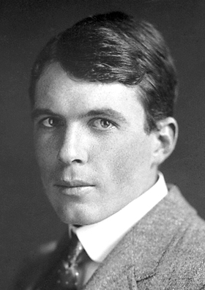
It would take Pink Floyd William H. Bragg, an Australian-born British physicist and X-ray crystallographer, to make that fact known in 1912 via Bragg’s law of X-ray diffraction. And what is crystalline but the firmament? There is much to be discovered but what seems apparent is that the firmament and our perception of the moon are in direct relationship with the other. Fun fact. Bragg was the director of the Cavendish Laboratory, Cambridge, when “the discovery” of the double-helix DNA structure was reported by Watson and Crick in 1953.
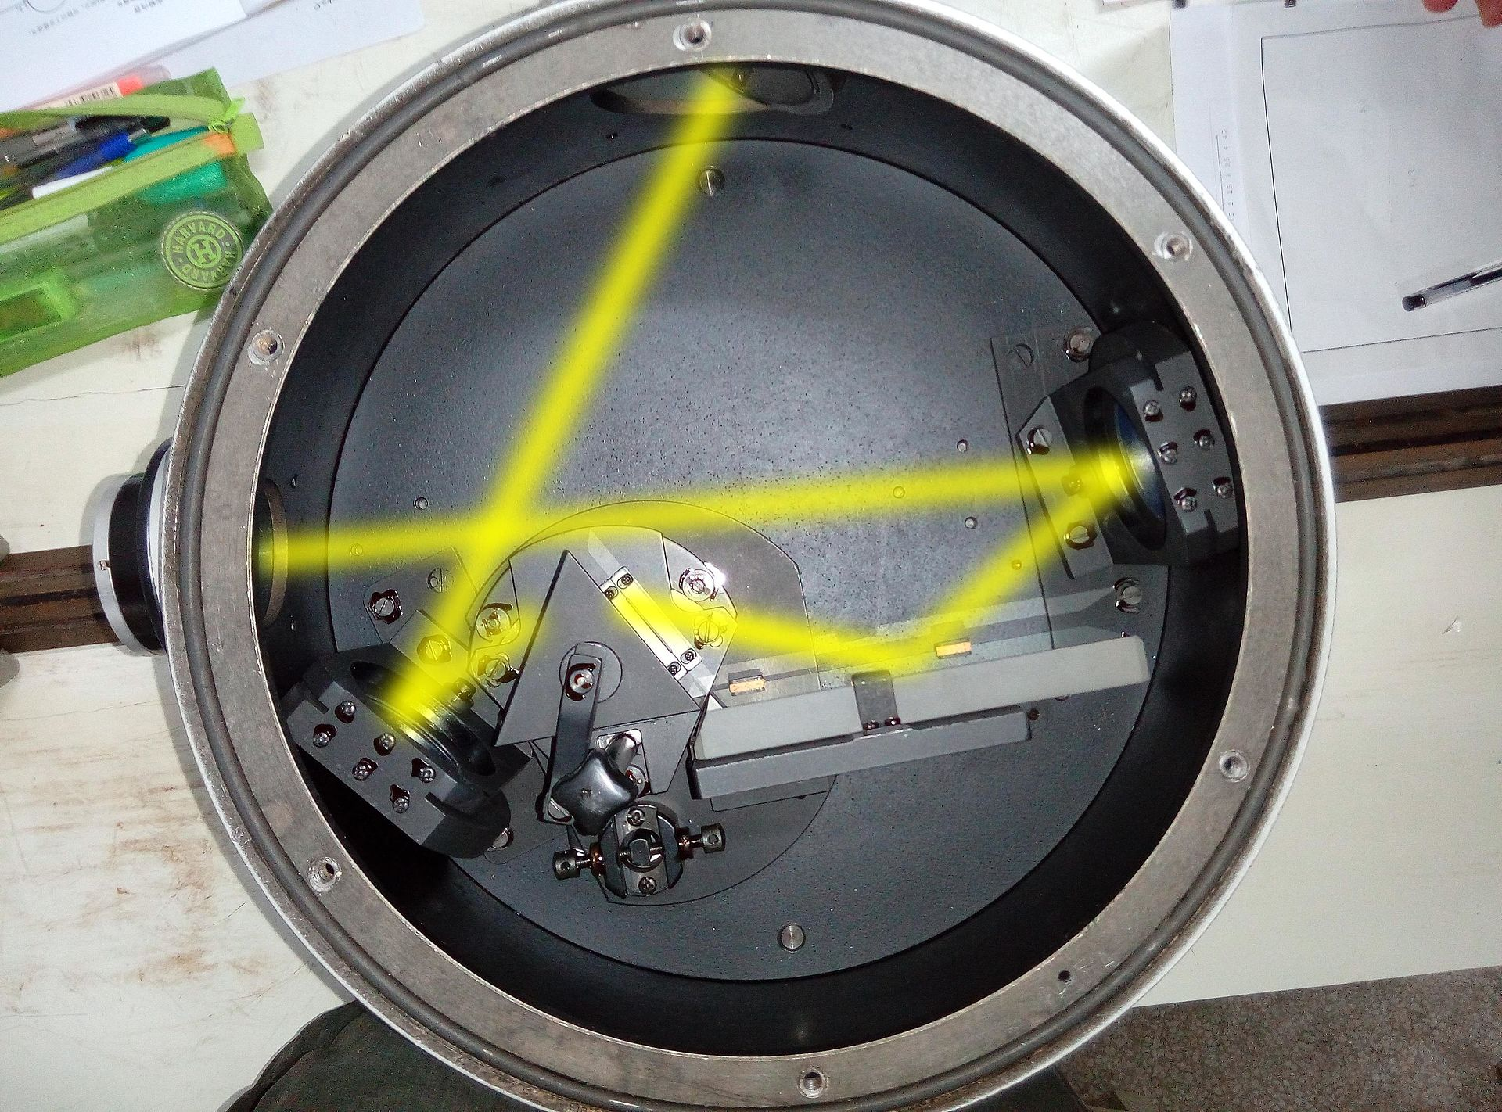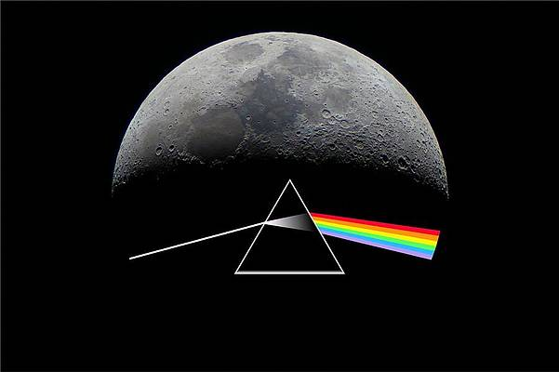
I made that joke about Pink Floyd several lines ago but was it really? Their most popular album cover depicts Bragg’s crystalline light as viewed through a monochromator, and yet it is called ‘The Dark Side of the Moon’. Truth in plain/plane sight is more like it. A monochromator in case you were wondering is an optical device that transmits a mechanically selectable narrow band of wavelengths of light or other radiation chosen from a wider range of wavelengths available at the input. Wordy, I know. I lifted that definition from Wiki. File a complaint with their department. The point is that a reflecting monochromator uses a single prism to redirect light. I have added a photo so that you can see how an x-ray beam would do just that in such an optical device.
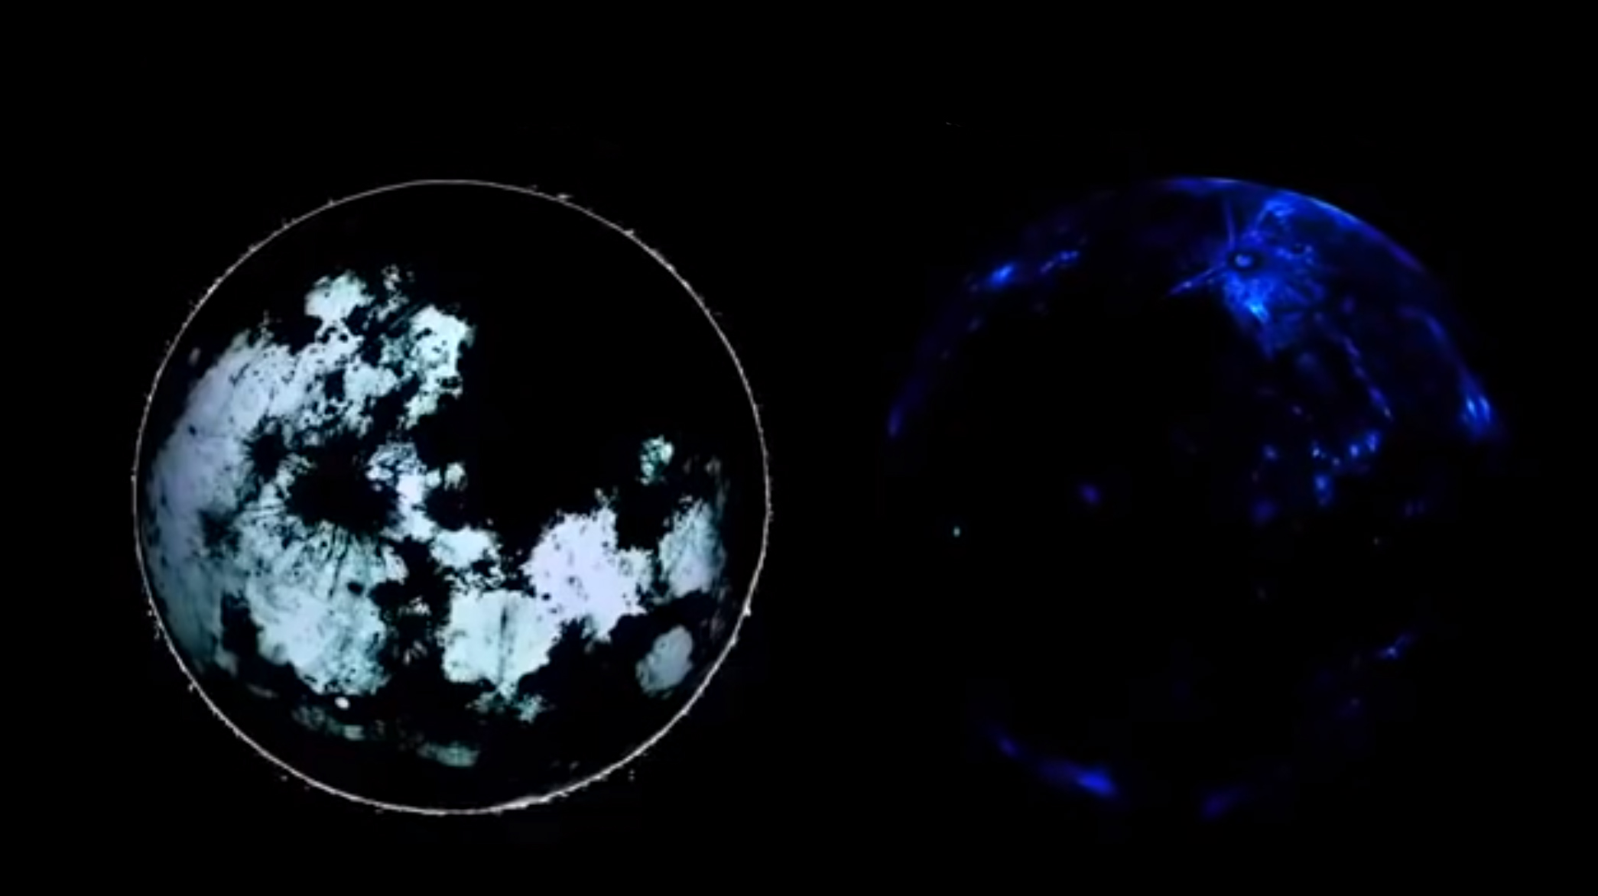
The redirected beams of an x-ray in the crystalline firmament probably explains what we are looking at in the moon and why it is a composite image; multiple pictures laid over the other. There are at least two fixed images that I can see. The most obvious is the skeletal land masses as seen from the perspective of an x-ray. You may have already noticed that the map is flipped from how we would naturally perceive it on any given full moon. That’s because it is first and foremost a reflection, a mirror image of the continents below.
The second image is of the firmament. The two images when superimposed upon the other depict a precise moment in time in a pre-diluvian world. You will recall that the firmament was formed on the second day of creation to separate the waters below from the waters above. The land rose above the waters on the third day and the moon was created on the fourth. My best guess is that the land masses as well as the firmament were captured and imprinted upon the moon at that precise moment. We are seeing the signature of YAHAUAHA Elohiym during the creation week.
Undoubtedly, the firmaments skeleton is captured from a different angle than the land masses. We are told the bellybutton for example is a crater called Tycho when in fact it represents the vortex at the highest point of the dome. The very center of our realm. You can actually see the rays stemming out from it like hemispherical ribs. Stop and think about it, the moon is the only known image of the firmament. It’s the firmament which gives the moon its spherical appearance.
Tycho was named in 1651 in honor of the Danish astronomer Tycho Brahe by somebody named Giovanni Riccioli. I checked. Riccioli was a Jesuit. Another astronomer to name the crater was Frenchman Pierre Gassendi. He called it Umbilicus Lunaris, which literally translates to ‘the naval of the moon.’ How adorable. Arthur C. Clarke chose Tycho in his novel ‘2001: A Space Odyssey’ to describe a strong magnetic field emanating from the crater. It is in Tycho where they discovered a black cube monolith, the source of the magnetic field. Again, adorable.
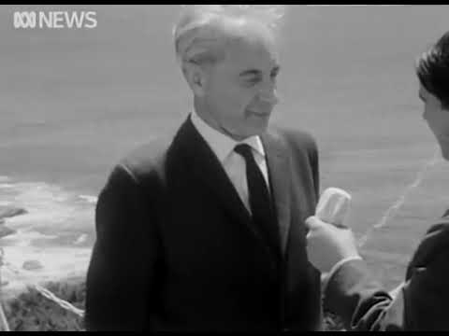
In 1965, some four shallow years before the Apollo moon landing hoax, the Elite drug American astrophysical Professor Among R Foster before the Media deliver the truth on the matter but then debunk it in the process. I dropped a link to his interview. Here is another. And since I am in a good mood, yet another. After the interviewer asks Professor Foster to explain his theory, here is his response.
“It is rather more than a theory. 10 or 11 years ago I stated to various scientists that the moon is not a piece or rock, but it is plasma—a plasma phenomena; cosmic plasma—and that this fact will eventually be confirmed. I made certain predictions which were already confirmed in 1958, and the situation now is coming close to a complete confirmation.”
The interviewer then asks Foster what the results of his theory will be if he is proved correct, in which Foster says:
“The results will be profound and decisive because it will give proof as a complete reinvestigation of the laws of nature is necessary. Because if the moon is a plasma, no man will ever land on it. The self-landing attempts will all fail.”
Well, that turned out exactly as Foster predicted. The Apollo 8 astronauts orbited the moon in 1968 and were like: “We were wrooooong and Professor Foster was totally legit all along. The moon is made of plasma. Guess we can’t land on it.” Continuing.
“That means that the mass of the moon is less, far less than is currently assumed. It’s in a different state of energy and it has far less mass. That means there is no more explanation for the tides. If the moon for example had only a thousand-part of its current mass, then the tides would only be two inches high and that means that if it is proof that the moon is a plasma then all gravitational theories are out and the new concept of the cosmos and of its laws has to be evolved.”
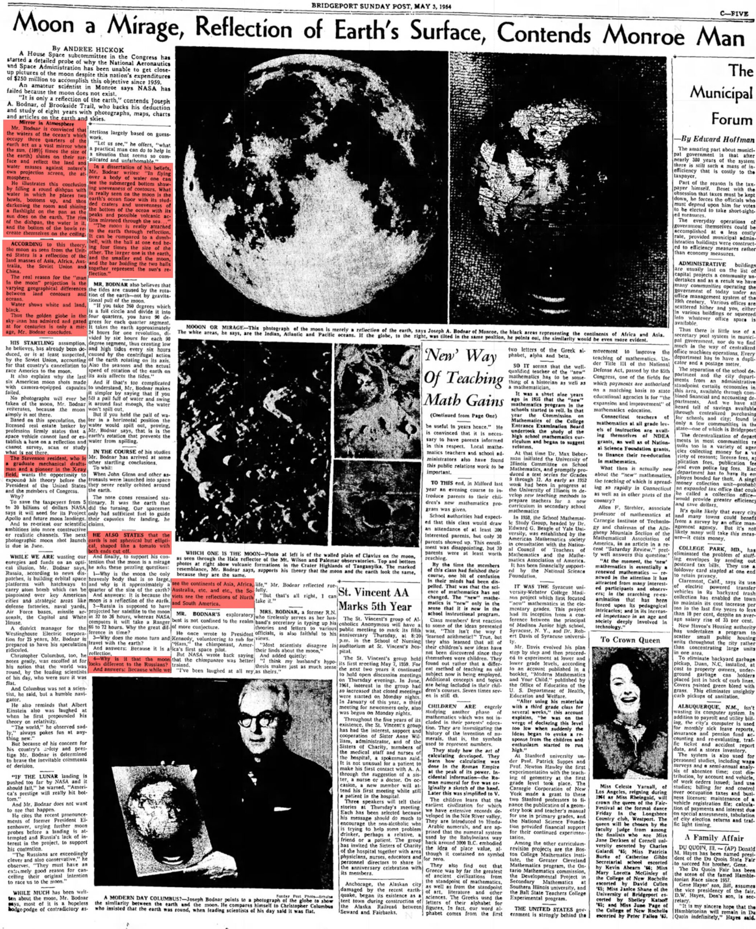
What Foster appears to be saying is that the space race was misdirection when in fact everything we know about the laws of Science as well as the greater realm is wrong, and our Controllers can’t have that. Best to debunk him with a hoax. Foster wasn’t the only one though. In 1964, Joseph A. Bodnar, a graduate mechanical draftsman and a pioneer in the X-ray field, was interviewed by the Media for his dedicated research to the idea that the moon was a reflection of the earth, only to be defeated by Buzz and the gang. He claimed the same thing I’m saying. Water shows white whereas the land is black, thereby indicating there is much more land out there than we are being told.
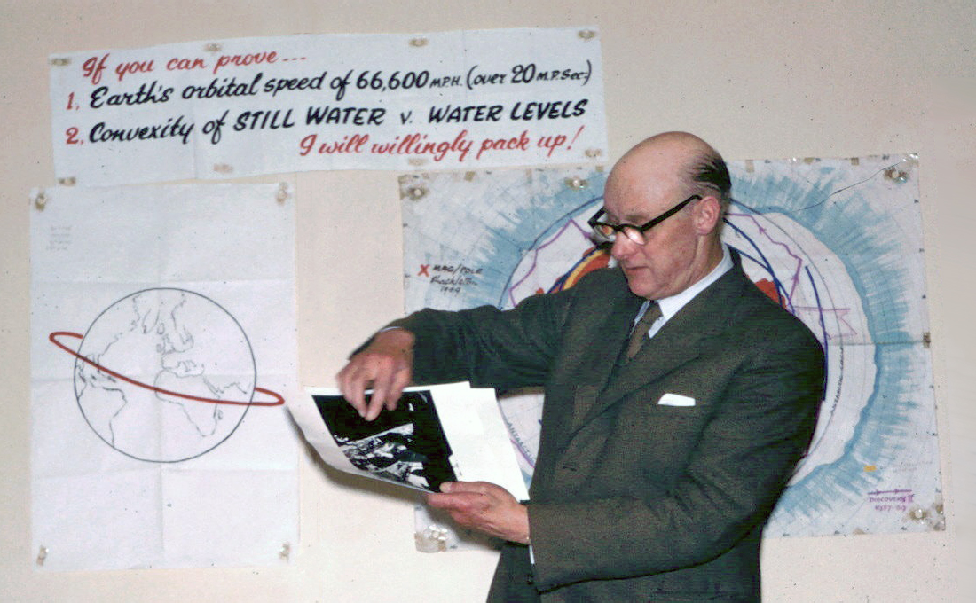
Flat earthist Samuel Shenton was drug out for the masturbatory ridicule of the Media for an entire decade for the same purposes. Whether or not any of these mentioned individuals were shills is secondary to the reality that our Controllers chose their research for an explicit purpose. Why our Controllers would go to such great lengths to perpetrate a flamboyantly royal hoax can best be explained in the ideas they were attempting to silence. The earth is a flat, motionless plane, and indeed the plasma moon is a map of the greater realm.
Also, Bodnar shared his reasons as to why he wanted to wake his fellow Americans up to the moon mirror reality. In his words, to save the taxpayers from 5 to 20-billions of dollars NASA says it would need for the Apollo moon landings. Bodnar threatened to pinch the pockets of our pimps and handlers, and they can’t have that.
Foster, Bodnar, Shenton and others whom I haven’t taken the time to mention were simply carted out for five minutes to show us what the ancients knew perfectly well to be True. A map of our realm could be located within the firmament, and I found one such example to prove it.
²⁰ And Benyamiyn beheld that instrument with the map of the stars of heaven, and he was wise and looked therein to know where his brother was, and Benyamiyn divided the whole land of Mitsriym into four divisions, and he found that he who was sitting upon the throne before him was his brother Yoceph, and Benyamiyn wondered greatly, and when Yoceph saw that his brother Benyamiyn was so much astonished, he said unto Benyamiyn, What hast thou seen, and why art thou astonished?
Yashar (Jasher) 53:20
It doesn’t outright say the moon is a map, nor are we told what the instrument is which he beheld to track down the whereabouts of his brother Yoceph, but Benyamin’s sleuth skills are non the less impressive, no? They were seated at the same table, both brothers. Benyamin hadn’t the faintest clue that the Egyptian was his brother until he gazed up at the night sky and tracked his coordinates. To the very room he was standing in no less. In explaining all of this, Benyamin is declared to be wise. Even in ancient times very few people were wise. Meaning that not everyone was capable of reading the skies like GPS. The wise men who searched out Messiah come to mind though. Perhaps it is true that only some of the ancients could comb the heavens, but none of them believed the earth was a globe.
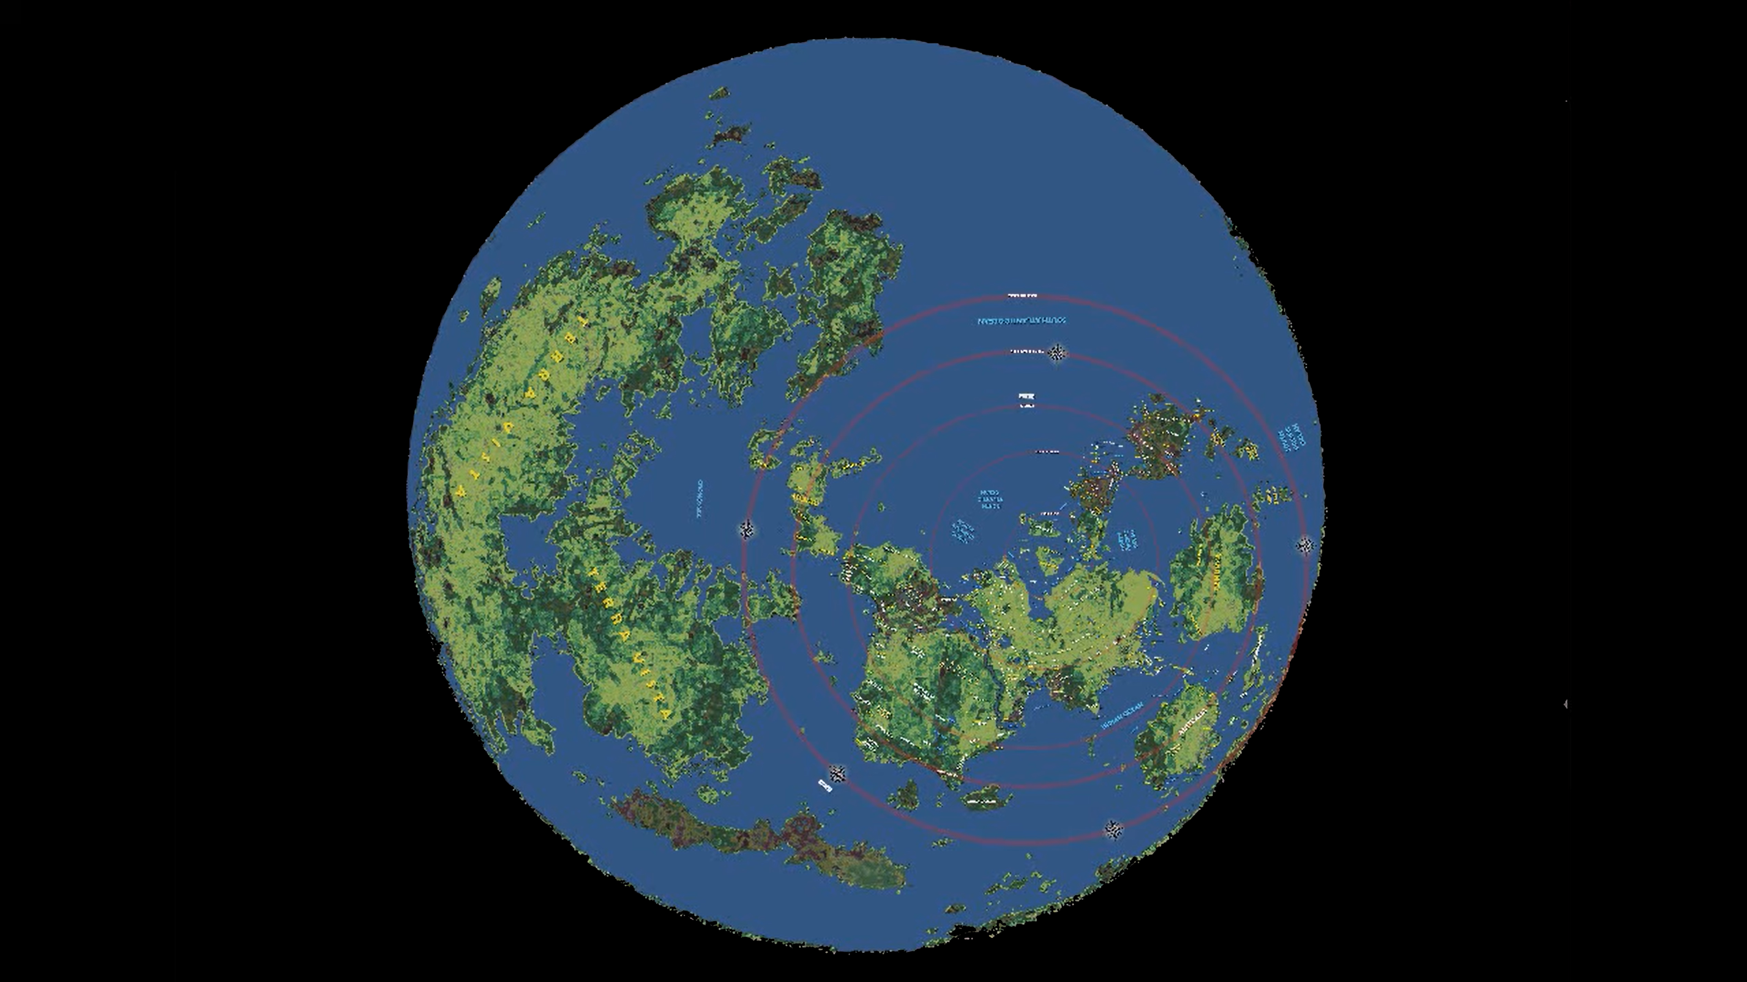
And so, there you have it. The moon map. Our greater realm. You thought I was making this up, didn’t you? You were waiting around taking bets, seeing if I’d really go through with it, weren’t you? Just look at that beauty. The Straight Road of the Elves should make perfect sense by this point. You have to sail beyond the curve to reach the flat world of old. I spy far too much land to fit on any one decorative globe they sell at Target.
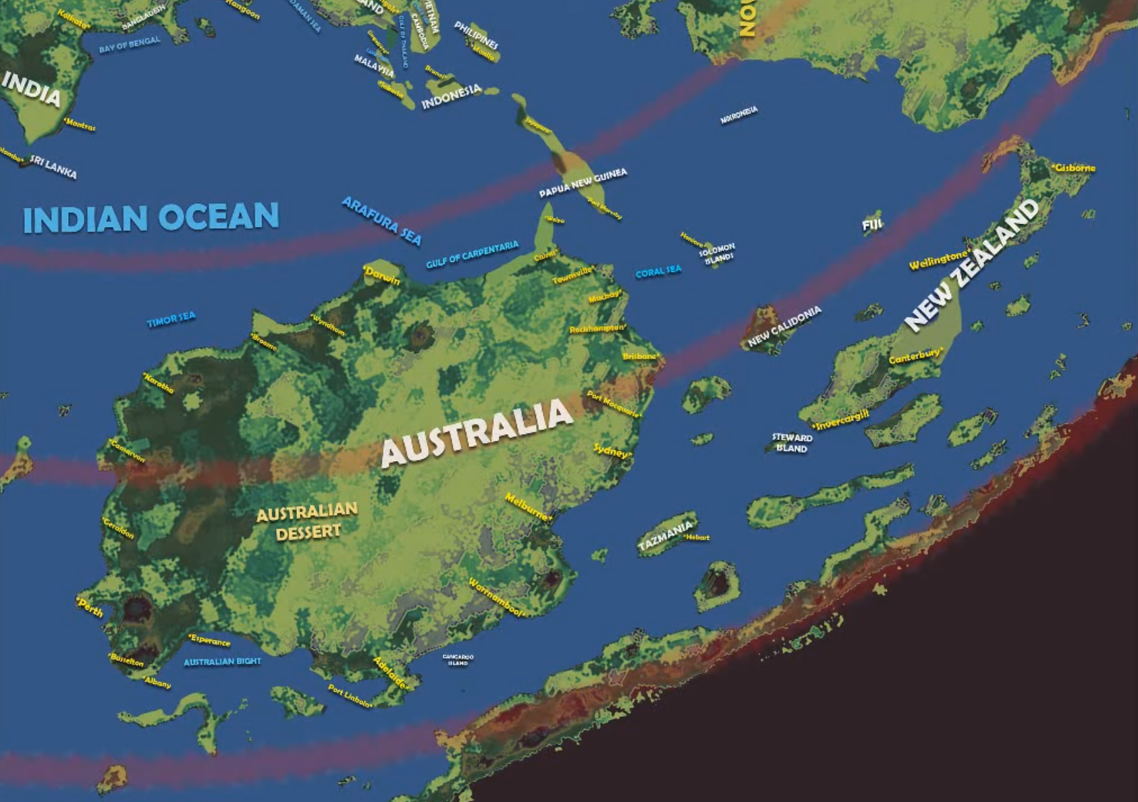
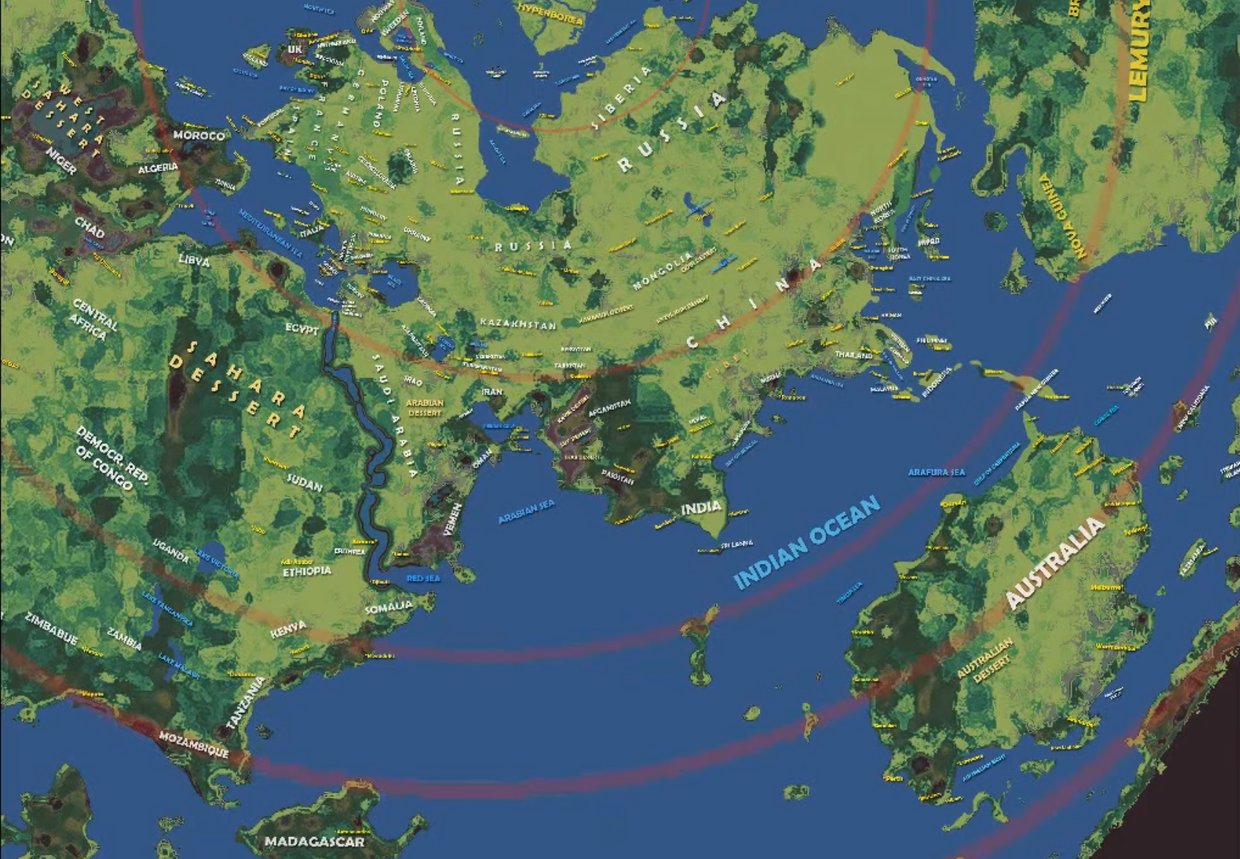
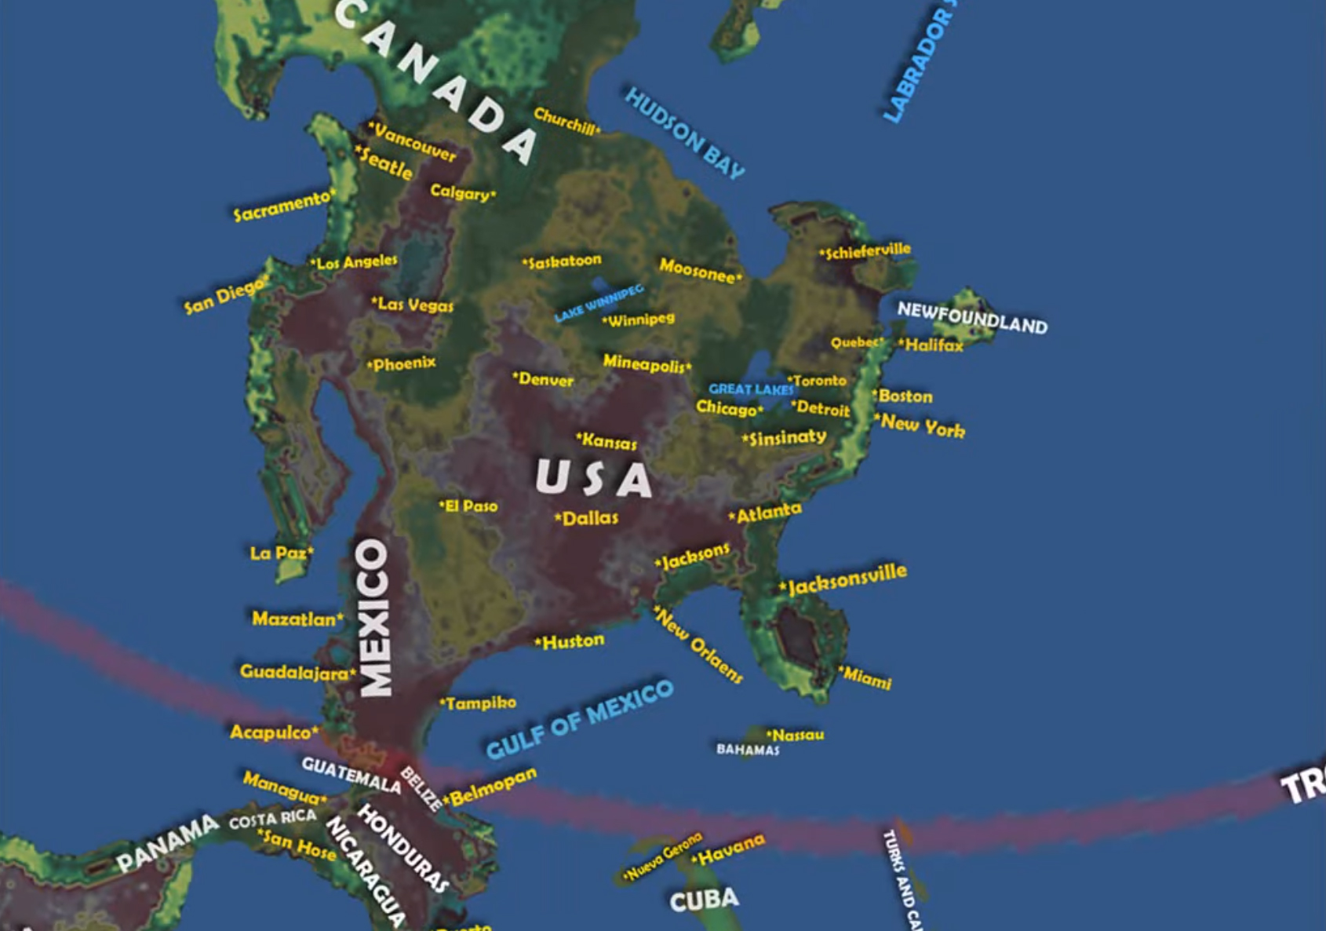
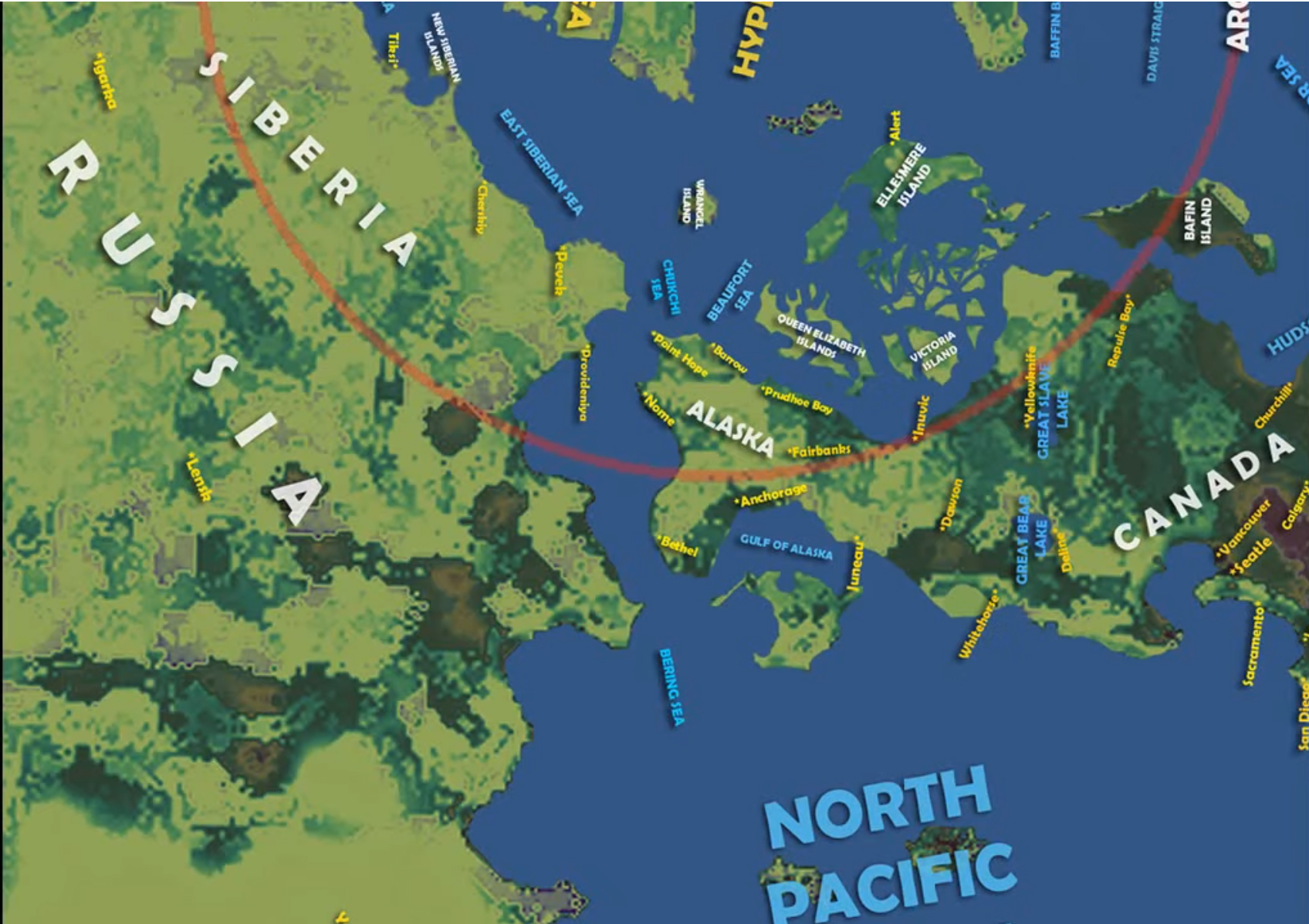
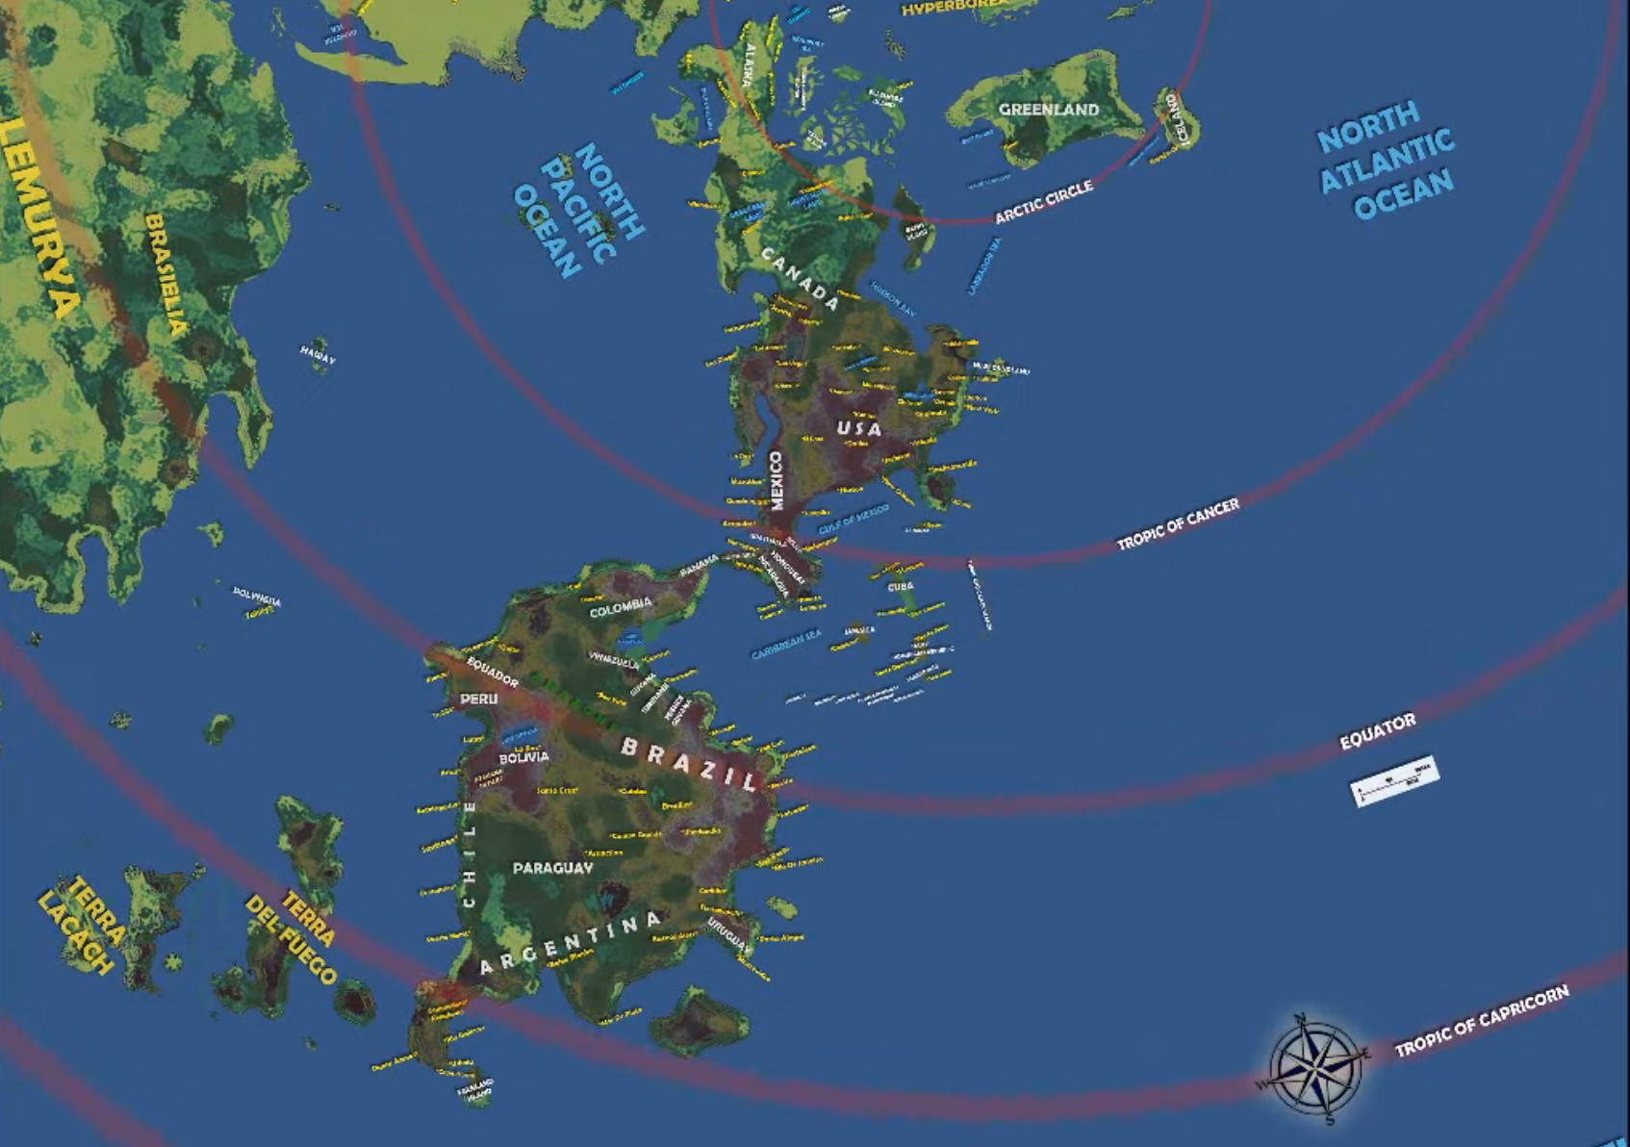
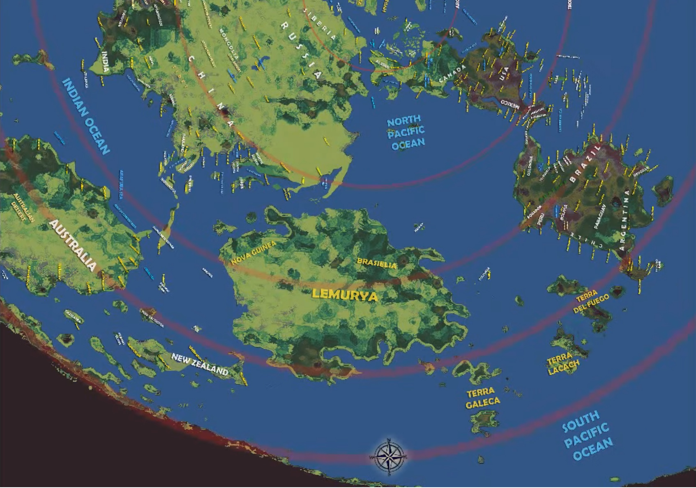
If you’re already confused, don’t be. I will be your tour guide. Our portion of the realm is located within the circular red lines on the right, denoting the circuit of the sun and the moon. A closer look will be given on the next page. Nearly everything outside those lines makes up the potential landmasses for the hidden wilderness. Quite the hunk of land too. It’s probably difficult to read but the name of the largest continent, according to this map, is Terra Vista. You could fit North and South America, Europe, Asia, Africa, and Antarctica in it and still have room to stretch out.

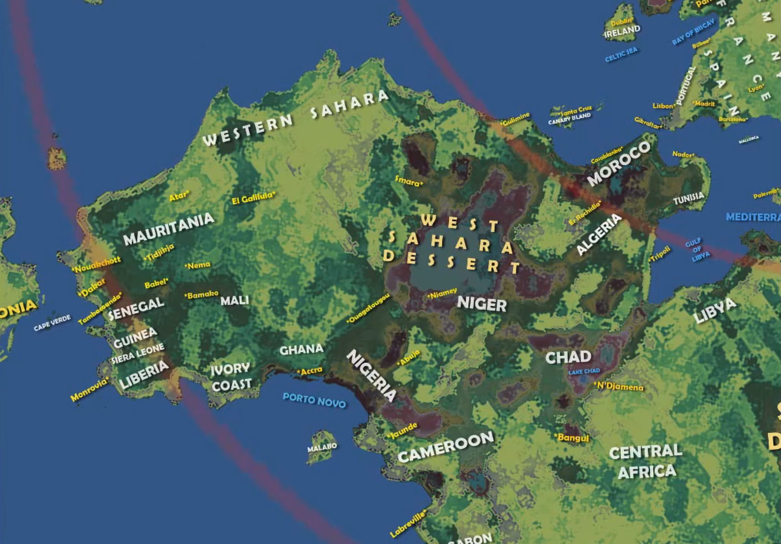
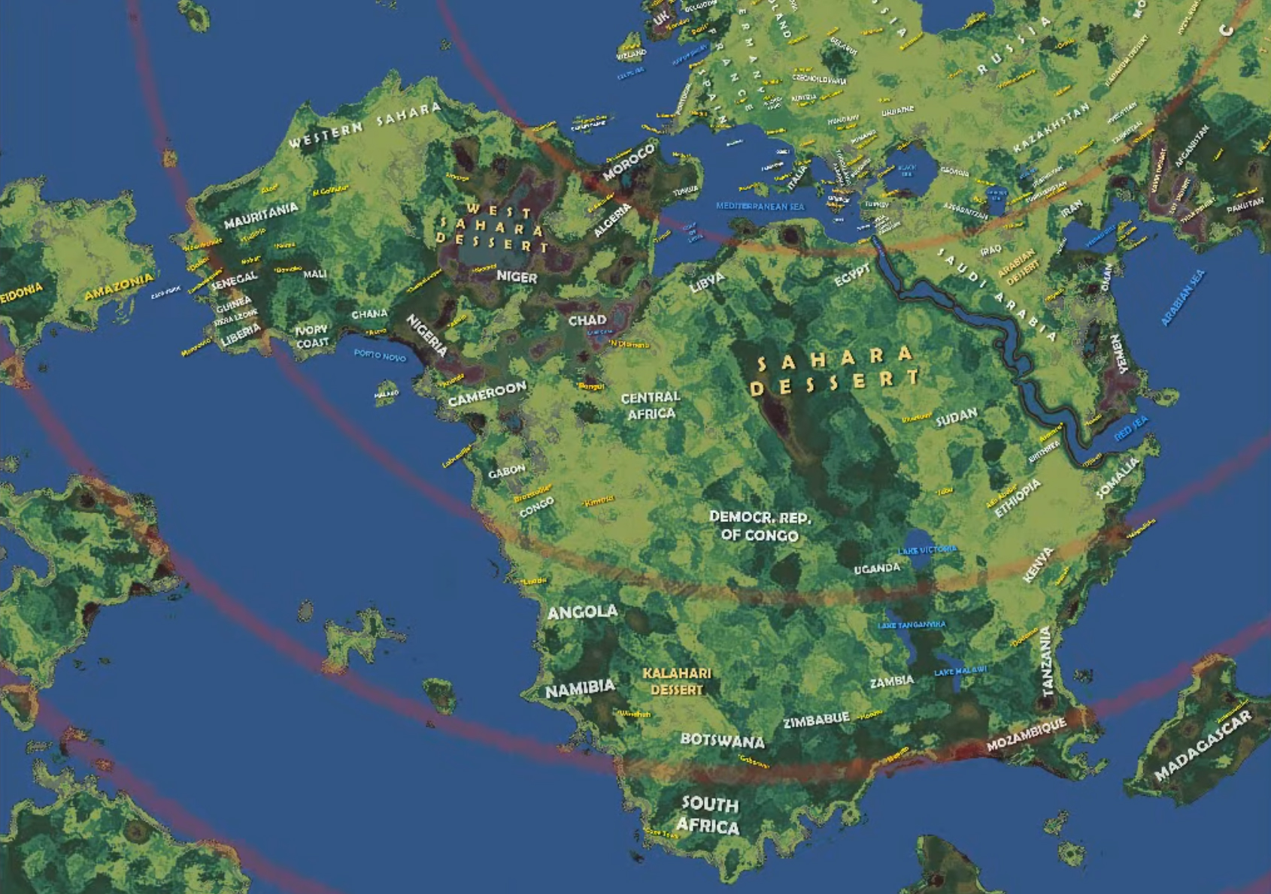
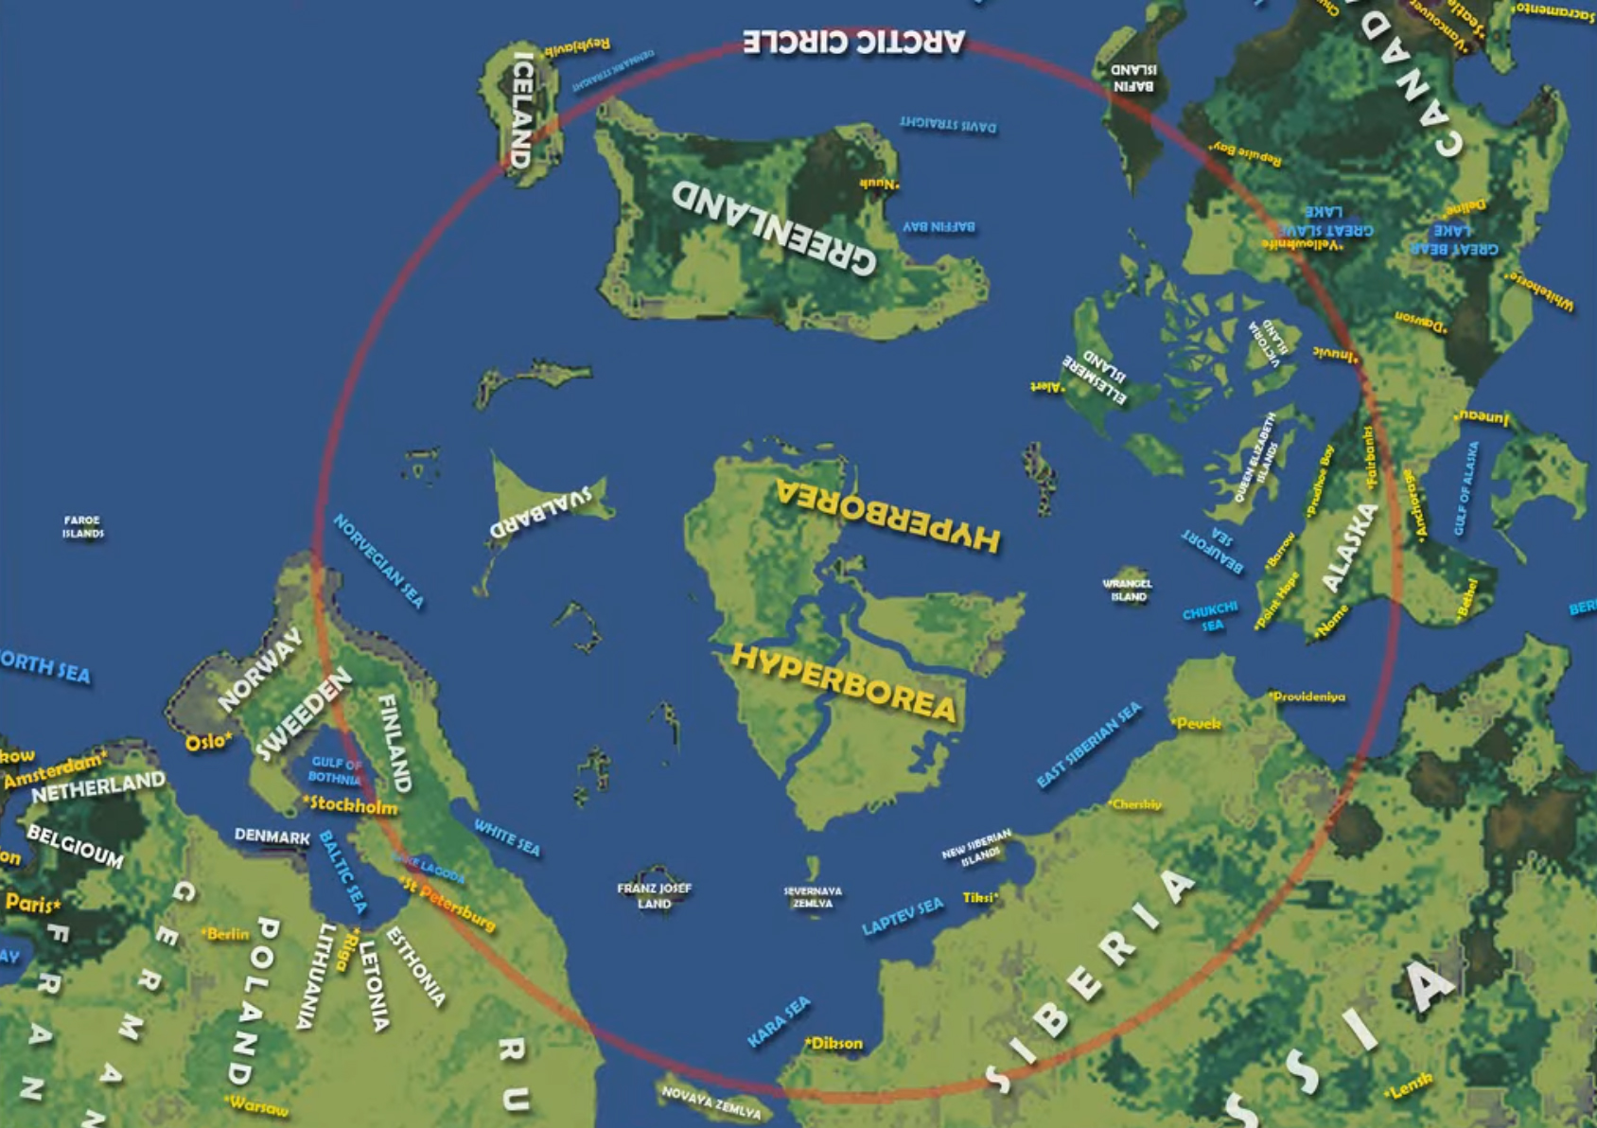
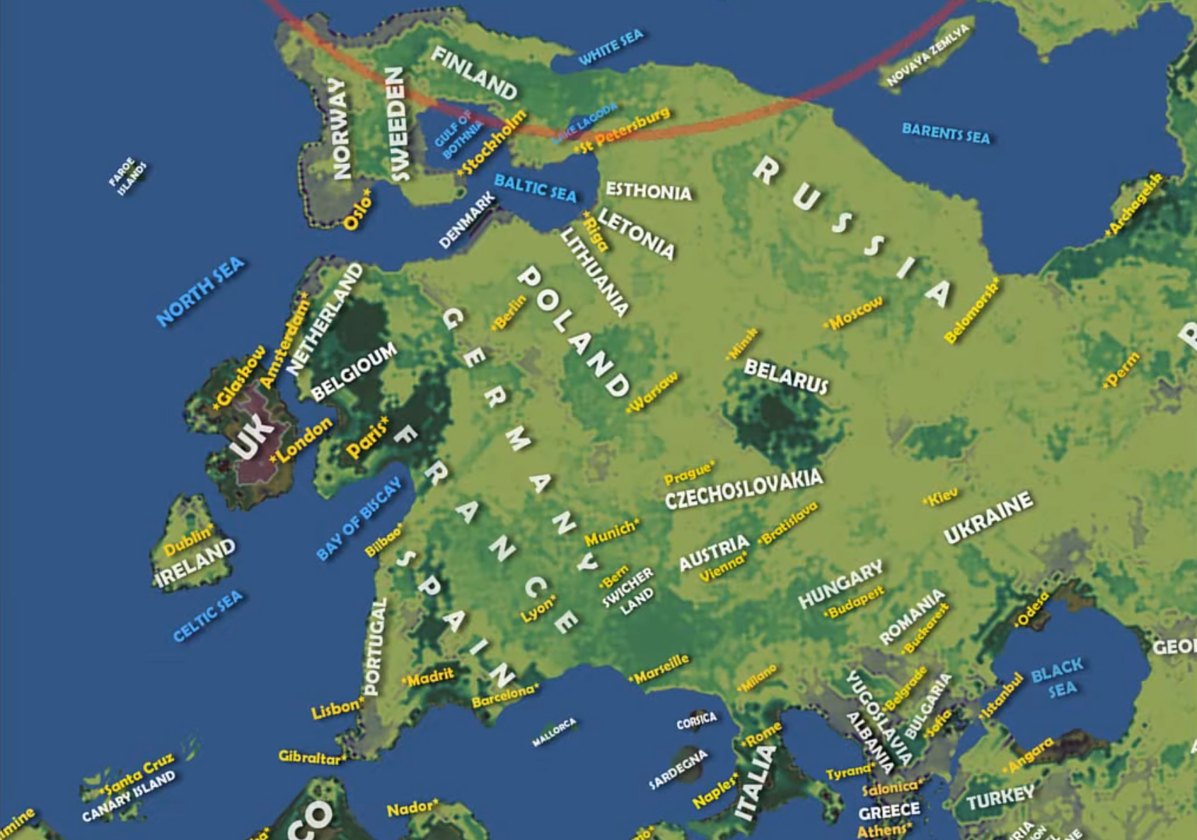
Credit is due to Vibes of Cosmos. He did the backbreaking work on this, not me. I’m just the currier. And so, now that you have received the package, I’ll give you a minute to comb through the stunning details of our realm as depicted on the moon. I spy Russia, Japan, Morocco, Madagascar, Spain, The UK, Canada, The United States, and Mexico. The existence of Hyperborea precisely as Mercator envisioned it has me excited. How in the world any of this can be explained by sheer coincidence is beyond me. It’s all there and more. The Red Sea is perfectly where it ought to be. Even the Black Sea is accounted for.
The lost continent of Lemuria is positioned east of Australia and India, precisely where it was hypothesized to be by our post mud flood inheritors, Philip Sclater and Helena Blavatsky. Blavatsky particularly declared its citizens to be of the third root-race, a subpar spiritual progeny but who built a civilization which far excelled anything dreamt up by the Egyptians or the Greeks, and that it was ultimately destroyed in a great deluge. Science has supposedly disproven the ancient knowledge put forward by those in the know (because Lemuria is a myth, you see) but the skies say otherwise. In a little while I will show you the sleight of hand. Lemuria still exists.
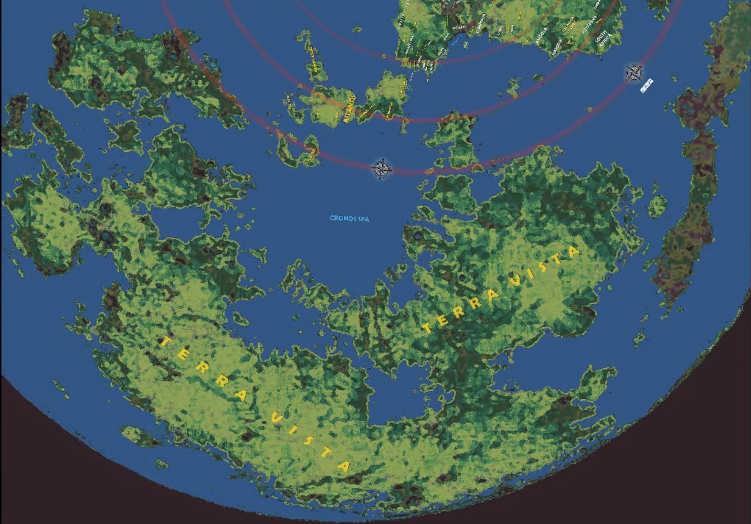
Before I get carried away with the particulars of our known realm, I probably needn’t remind you that the purpose of this paper is to talk about the hidden wilderness. The land beyond the reaches of the sun and the moon. On this map we know it as Terra Vista. Residents of the hidden wilderness undoubtedly refer to it by another name but seeing as how Terra Vista essentially means “land with a pleasant view,” I won’t argue.
Some have claimed the unseen land is a wasteland of darkness and ice, of chaos and the void, and therefore uninhabitable. Such a place is even recorded in Chanok, wherein we read:
⁵ I saw every large river, until I arrived at the great darkness. I went to where all of flesh migrate; and I beheld the mountains of the gloom which constitutes winter, and the place from which issues the water in every abyss. ⁶ I saw also the mouths of all the rivers in the world, and the mouths of the deep.
Chanok (Enoch) 17:5-6
Chanok testifies to a mountainous land of endless gloom and winter, but then look at what it is in connection with. The place where all flesh ends up. He is inferring to a migration of souls. The entryway to Sheol. Another hint is given when he notes the place from which issues the water in every abyss. I am more inclined to conclude he is speaking of Hyperborea, the location of our magnetic north.
And anyways, the gloom of winter is certainly true of other portions beyond our own. I will get to that in a little while. But first, I will remind you again of the accounts given to us regarding light of a different nature. That lines up with what can be read in the very first chapter of our Bibles. The Light was flipped on the first day of the creation week, though the sun wouldn’t show up for another few days. You probably already know where I’m going with this. I have learned however never to assume. And so, here you go.
1 IN the beginning was the Word, and the Word was with Elohiym, and Elohiym was the Word. ² The same was in the beginning with Elohiym. ³ All things were made by him; and without him was not anything made that was made. ⁴ In him was life; and the life was the light of men. ⁵ And the light shines in darkness; and the darkness comprehended it not.  Yochanon (John) 1:1-5 | ²³ And the city had no need of the sun, neither of the moon, to shine in it: for the glory of Elohiym did lighten it, and the Lamb is the light thereof.  Chizayon (Revelation) 21:23
Yahusha Ha’Mashiach was the light at the beginning. On those first few days. Some will claim Yochanon is speaking merely of an esoteric light. An inward spark if you will. That may be so, but Yochanon has so much more on his mind. Revelation helps to clear things up, and why I dropped both passages side-by-side. It’s in New Yerushalayim where we come to learn that the Lamb is the electrical wiring for the entire establishment. Not to say that the sun and moon are done away with. They’re simply no longer required. You will tell me my theory is bonk if the context is New Yerushalayim and the city hasn’t come down yet. No, it isn’t. Just because the Lamb is the light inside the city doesn’t mean he ceases to be a light outside of the city. Where Yahusha goes, so goes the lamp. And then look at what we read in the Legends of the Jews.
The light created at the very beginning is not the same as the light emitted by the sun, the moon, and the stars, which appeared only on the fourth day. The light of the first day was of a sort that would have enabled man to see the world at a glance from one end to the other. Anticipating the wickedness of the sinful generations of the deluge and the Tower of Babel, who were unworthy to enjoy the blessing of such light, God concealed it, but in the world to come it will appear to the pious in all its pristine glory.
The Legends of the Jews: Volume I
The light of Creation was the sort of quality which enabled men to see the world at a glance from one end to the other. No more atmospheric lensing. You could stand on the shoreline of California and wave a “G’day mate!” to someone in Australia. It’s all rather awkward if the earth was a globe, seeing as how there’s apparently a curve just beyond the horizon. Must have had eyes that matched those Elvin ships if they were expected to see from one end to the other, wink-wink. Meaning that the view from Terra Vista today must be spectacular indeed because look at what else we read. In the world to come the light of creation will appear to the pious in all its pristine glory. Not to the impious though. Just the pious.
No wonder why the hidden wilderness won’t be revealed until the sinners are snuffed out into the darkness of their design. When the light of the Lamb finally makes itself known, the hidden wilderness will be revealed in so much as the righteous will be able to wave shalom to the residents of Terra Vista from wherever they find themselves on the moon map.
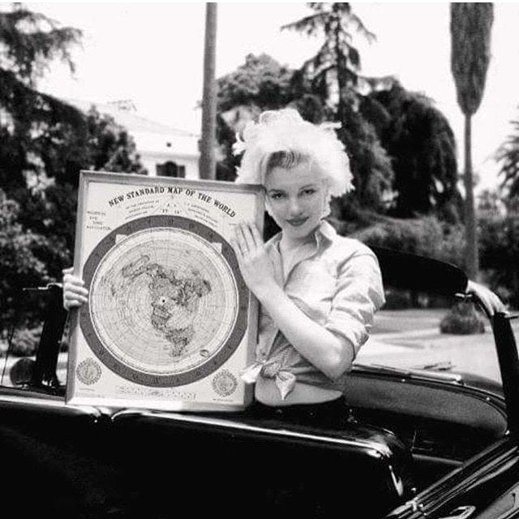
Many Antarctica’s
[UPDATE 11/3/2022]
IN reply to the individual requesting some years ago that I write a paper on Antarctica’s location in the flat earth realm, this is for you. I have finally gotten around to it, but sadly not before the second decade of the twentieth century came to an end. Back then I would have shown a picture of the Azimuthal equidistant projection map, particularly the proposed outer ring of the world, and then called it a day. Mm-hmm, Marilyn knew. For obvious reasons, the situation regarding our greater realm has changed Antarctica’s identity, but only slightly.
Some of you are thinking there can’t possibly be an Antarctic ring around the realm if the moon map is true. The moon map is totally legit and they’re both correct. I’ll do my best as to show you why. The ring still exists because the firmament exists. It’s simply larger than we suspected. Others are adamant that the AE map was invented by our Controllers. That may be. Most likely because it is their portion of the realm. They control it. The dragon swept a third of the stars from heaven in Revelation 12:4 and flung them to earth. What is one-third but 33? Oh dear. The beginning rank of any true Freemason is 33. And so, if I had to take a wild guess, I would say the AE map makes up 33 percent of the greater realm. There is that magic number again. It’s a shot in the dark but I wouldn’t be in the least bit surprised if that turns out to be true.
[EDIT: It is true. All of it. My thought about our entire known realm being only 33 percent of the greater whole. I scrambled upon the following passage a few minutes ago.
It takes five hundred years to walk from the earth to the heavens, and from one end of a heaven to the other, and also from one heaven to the next, and it takes the same length of time to travel from the east to the west, or from the south to the north. Of all this vast world only one-third is inhabited, the other two-thirds being equally divided between water and waste desert land.
The Legends of the Jews: Volume I
And there you have it. Read it and weep. The 33 number. The other two-thirds constitute a desert wasteland. Our hidden wilderness.]
Still, if Marilyn is not to be trusted as the sort of loose-lipped ship sinking girl who’s bedded with somebody in the know, then I will refer you to Barrack Obama speaking at the United Nations. And if you’ll recall, he doesn’t have time for the Flat Earth Society. I swill specifically direct your attention to the United Nations logo underneath Obama’s podium. Feel free to exchange glances between Obama and Marilyn. Take all the time you need.
The UN logo includes a laurel wreath rather than the Antarctic ring, and isn’t that interesting? The laurel wreath is an ancient symbol denoting victory and conquest. Peace and safety through totalitarian rule, that sort of thing. Visions of Caesar are easily conjured. Or perhaps the Olympic games. One can envision “light-bearers” carrying the torch of illumination all over the world before the opening ceremony begins, after which the laurel wreath is handed out as a crown to its victors. And you’ll never guess who originally wore the laurel wreath. I checked. It was Apollo.
You will tell me Marilyn was simply a fan of United Nations speeches and also of measuring flight paths in her spare time. Marilyn must have been a fan of the World Health Organization then. That’s probably it. I invite you to pay careful attention to the WHO logo, because they were not simply content with a laurel wreath surrounding their portion of Yahuah’s creation. No, they decided to show us the method by which the world would be conquered, and that is with the staff of Hermes, complete with a coiling serpent. Alchemy. If you obstinately tell me that there is no connection whatsoever between Apollo and Hermes and a worship of the serpent as well as pharmaceuticals, then you are once again letting cognitive dissonance win the day. Please stop doing that. Can you hear it? Listen closely. Somebody’s whispering in the wind: “The Earth is flat.” It seems like just about everybody but the gullible public are well aware of that fact.
Really, come to think of it, a laurel wreath surrounding Yahuah’s creation, even if it is only their conquered portion, couldn’t be any more perfect for the present globe earth deception. Iyov (Job) 38:14 tells us that the earth “takes on form like clay under a seal.” This is in reference to a king’s seal or signature, a signet ring sealing a letter with hot wax, which is the Earth in this scenario. Perhaps you can better understand what Satan and the elohiym have done to His realm. They have ultimately transgressed upon and conquered something that was never there’s to begin with.
He has inscribed a circle on the surface of the waters
At the boundary of light and darkness.
Iyov (Job) 26:10 [NASB]
I have come prepared with several passages in Scripture which describe the edge of the greater realm. This is just one of them. And as you can see, Yahuah has inscribed the surface of the waters with a circle which furthermore denotes the boundary between light and darkness. Several years ago, I would have mistaken the laurel wreath and Antarctica as the circular ring of our world, in part because the revolution of the sun and the moon form a circuit within it. The Antarctica part is partially correct, but certainly not the greater circle as seen on the moon map. We’ve been over that already. Give me more time and I will show how the Antarctica deception works. Continuing without interruption.
²⁷ When He prepared the heavens, I was there, When He inscribed a circle on the face of the deep,
²⁸ When He set the clouds above, When He made the fountains of the deep strong,
²⁹ When He gave to the sea its law, So that the waters would not transgress His mouth, When He inscribed the foundations of the earth…
Mishle (Proverbs) 8:27 [The Scriptures]
Reading on.
⁸ Or who enclosed the sea with doors, when it burst forth and came from the womb;
⁹ when I made the clouds its garment, and thick darkness its swaddling band;
¹⁰ and assigned for it My law, and set bars and doors;
¹¹ and said, ‘This far you have come, but no farther, and here your proud waves stop?’
Iyob (Job) 38:8-11
Reading on.
All the rivers and streams of water go and flow into the waters of the ocean which surround the world like a ring, and the ocean is not full, and to the place where the streams go and flow there they go again through the channels of the sea.
Ecclesiastes 1:7 [Targum]
Reading on.
¹ And then I made firm the heavenly circle, and (made) that the lower water, which is under heaven collect itself together, into one whole, and that the chaos become dry, and it became so.
² Out of the waves I created rock hard and big, and from the rock I piled up the dry, and the dry I called earth, and the midst of the earth I called abyss, that is to say the bottomless, I collected the sea in one place and bound it together with a yoke.
³ And I said to the sea: Behold I give you (your) eternal limits, and you shalt not break loose from your component parts.
⁴ Thus I made fast the firmament. This day I called me the first-created.
2 Chanok 28:1-4
It is only appropriate that my search for the outer ring took me far and wide within the pages of Scripture. How fun that 2 Chanok as well as the Ecclesiastes Targum is represented in the quest. By all accounts the earth takes on the shape of a circle or a ring. There are limits, but we never once read that Antarctica is it. Ecclesiastes 1:7 simply says the oceans surround the world without ever mentioning an ice wall. Passages such as that one might lead some to conclude that a person would sail right off but then look at how 2 Chanok describes the situation. There is a heavenly circle defined by eternal limits. That’s the firmament being insinuated. It is the firmament ensuring that the waters are properly compassed about. The way I imagine this is very much like the ending to ‘The Truman Show.’ Somebody sails towards the horizon until they thump right into it, should they even be capable of making it that far.
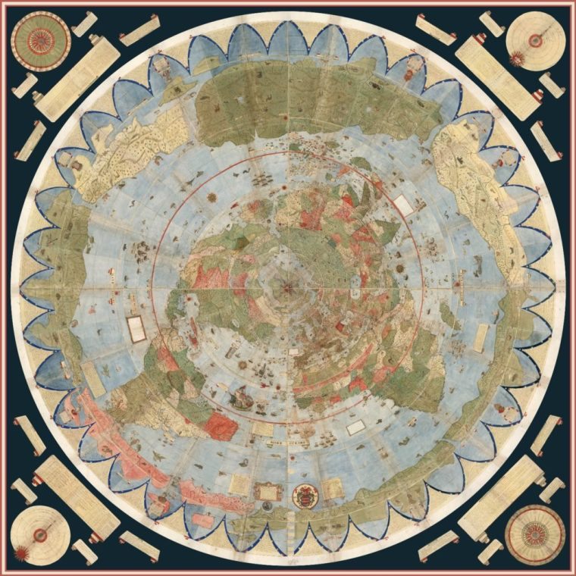
Captain Cook is said to have made a 6,000-mile journey around the Antarctic Circle in 1772. An interesting number seeing as how 6,000 years is the timeline that we’re expected to go with in the Masoretic rather than the 7,000 in the LXX. Technically, Cook never saw Antarctica. Nobody did until after the mud flood event, or rather, the Napoleonic Wars. I say this because there’s no possible way that Antarctica was unknown before Fabian Bellingshausen of Russia or Edward Bransfield and William Smith of Britain set eyes upon the continent, and only days apart from each other in 1820. There are maps which prove otherwise. I have shown them.
The 1587 Urbano Monte map has also been shown in other places but might as well do so again. Take a good look at it. Beautiful, I know. Don’t fight the tears. Cry if it is required of you. For starters, the year actually reads “I”587. But then pay attention to Antarctica. There’s no snow on it. It’s inhabited with exotic creatures, telling us that the map is much older than the sixteenth century. I’m wondering now if the ice was intended to keep intruders out of the undying lands at a later hour. And another thing, Antarctica may take on the appearance of a ring, but there are canals leading through it as well as water on the other side. They’re separate continents, not one. The realm is much larger and goes well beyond what we are ever shown.
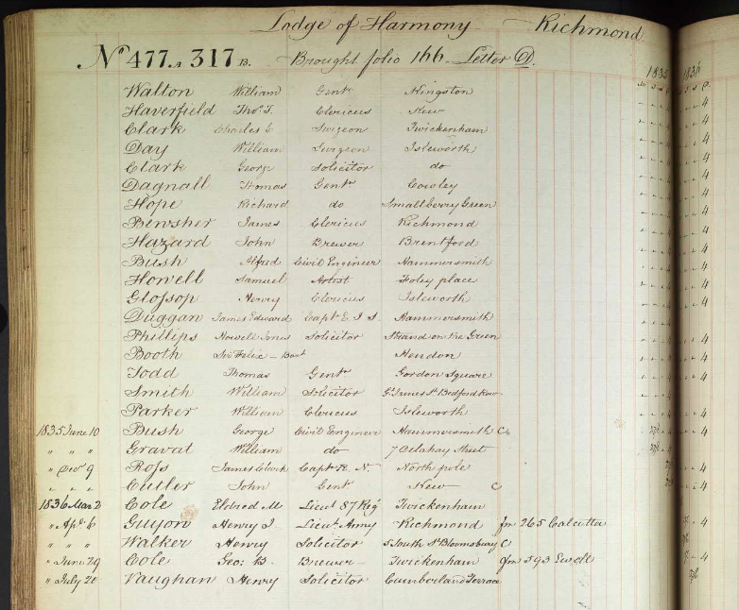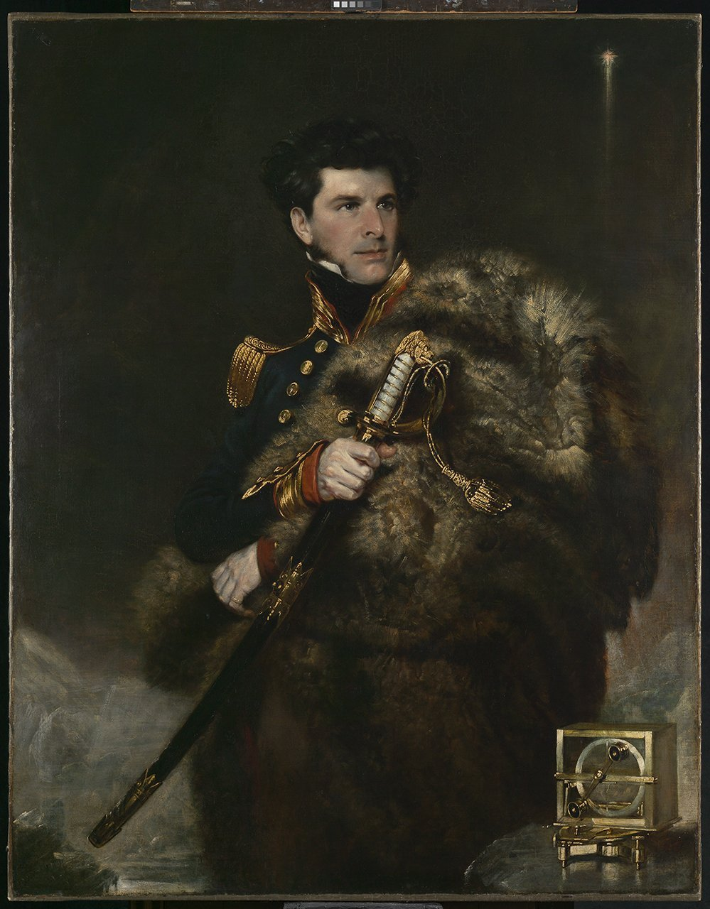
The “Ice Wall” was apparently first discovered by British Naval Officer Sir James Clark Ross during his 1839-1843 expedition to Antarctica. I checked. Ross was a Freemason. By the time of his initiation into the Brotherhood on December 9, 1835, Ross had already “discovered” the north pole. This apparently explains why the Lodge listed the North Pole as his place of residence. How adorable. His voyage to Antarctica was a follow-up attempt to determine the position of a proposed south magnetic pole. It was the Ice Wall which stopped him. Upon confronting the massive boundary marker of ice, he famously remarked:
“It was … an obstruction of such character as to leave no doubt in my mind as to our future proceedings, for we might as well sail through the cliffs of Dover as to penetrate such a mass.
It would be impossible to conceive a more solid-looking mass of ice; not the smallest appearance of any rent or fissure could we discover throughout its whole extent, and the intensely bright sky beyond it but too plainly indicated the great distance to which it reached southward.”
Ross and his expeditionary fleet sailed around the Ice Wall for a great number of months. Between pit stops at the Cape of Good Hope and his polar expeditions, he spent the next several years of his life circumnavigating the southlands vainly in search of a passage to the other side, or so we’re told. The reality is that there are several ice walls, not just one, even if we are to go by the official narrative. Ross’ inability to find the imaginary magnetic south pole or whatever disproves the greater realm only so much as the Christopher Columbus story, wherein he went seeking for a passage to India but happened upon hundreds of miles of American coastline instead. For all I know, the British Admiral was seeking out the location of the Camp of Yah, seeing as how it likely wasn’t found in Hyperborea.
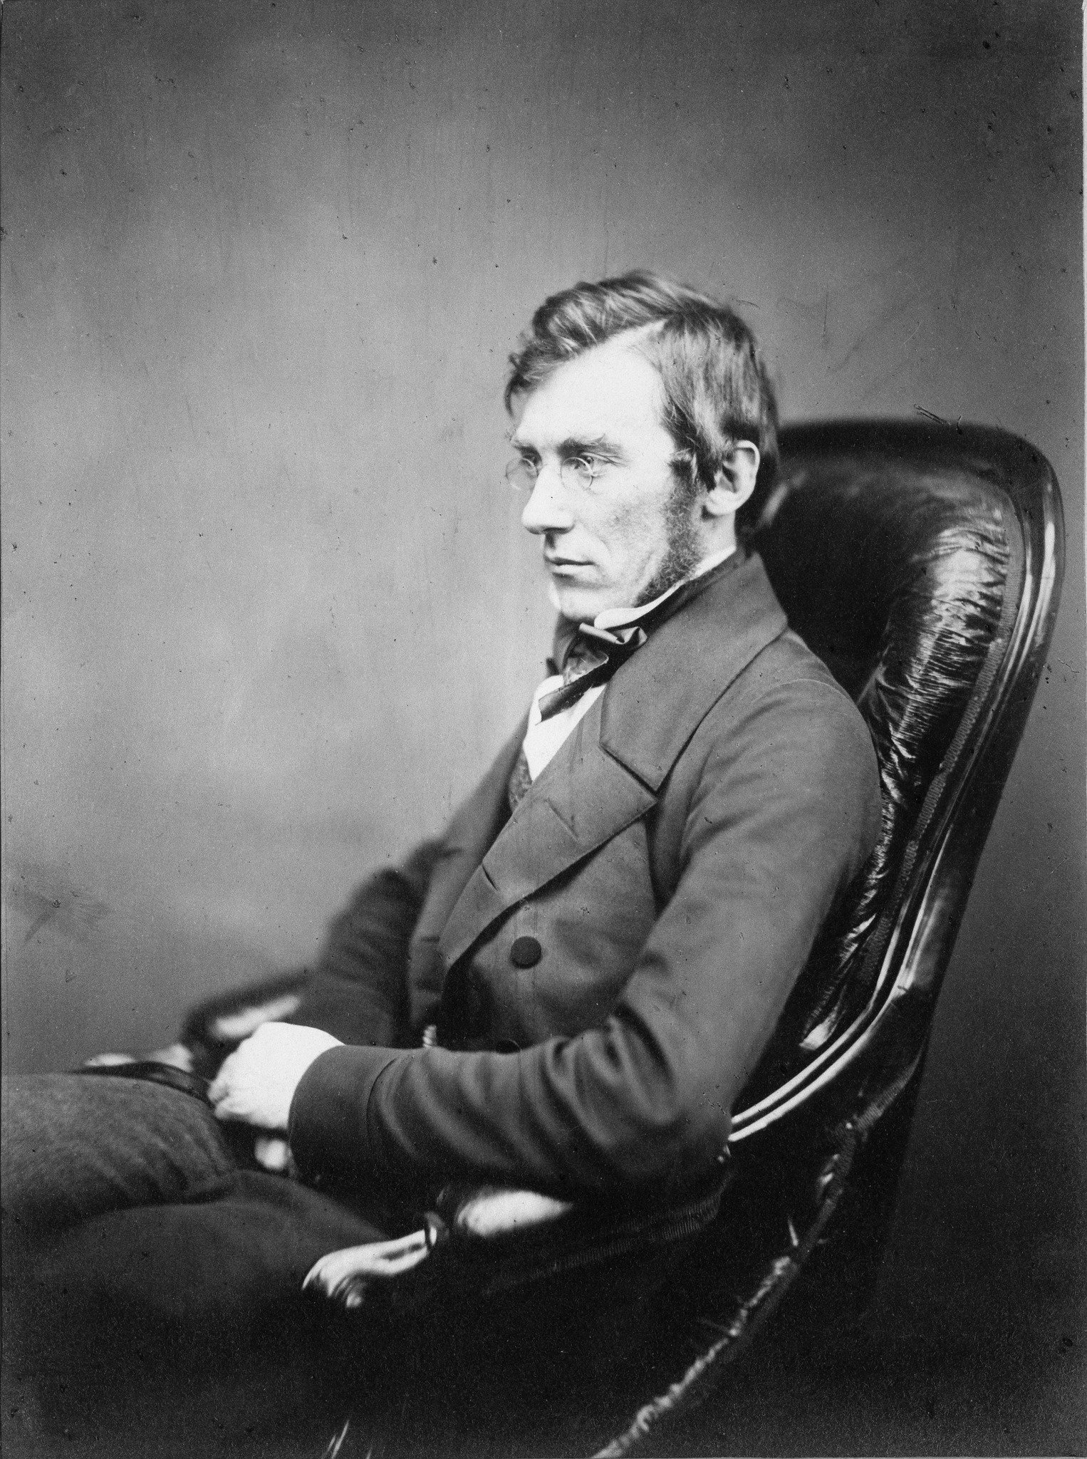
Fun fact. This guy was on Ross’ Antarctica voyage. Joseph Dalton Hooker is his name. It was while on the Erabus, staring up at the impenetrable ice wall, that Hooker spent his lonesome hours reading Charles Darwin’s Voyage of the Beagle, which had been personally provided to him by Charles Lyell. It should be noted that Hooker and Darwin were good friends. Their correspondences began after Darwin’s return from the Galapagos Islands and continued unhampered throughout his development of the evolutionary theory. In 1858 Darwin wrote that Hooker was “the one living soul from whom I have constantly received sympathy.” At the historic debate on evolution held at the Oxford University Museum on June 30, 1860, it was Joseph Hooker, alongside Thomas Huxley, who defended it. I just thought I’d let you know the sort of people whom we’re dealing with.
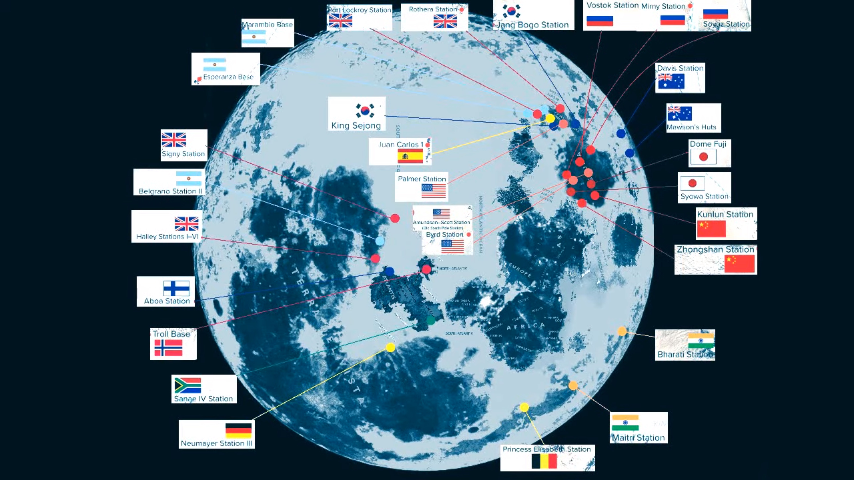
Well, here is what Antarctica really looks like according to the map in our firmament. In this unexpected cosmology, we are dealing with many Antarctica’s rather than just one. All those varying dots represent a different landing point. You might be wondering how such a conclusion was reached. Credit once again goes to Vibes of Cosmos. What he did is measure the distance between each reported Antarctic base camp with their respected countries as they are represented on a globe and then match them up with those location on the moon map.
Most can be found on the opposite end of the world than the unseen realm. Remember the lost continent of Lemuria? They’re camped upon it. And look, there is the Byrd station! Seems more apparent than ever what Admiral Byrd was talking about in that cranky old man interview when making the rather peculiar claim:
“Strangely enough, there is left in the world today, an area as big as the United States, that’s never been seen by a human being. And that’s beyond the pole, on the other side of the south pole from Little America.”
He’s not referring to the hidden wilderness. North and South America can be found to the east of Lemuria and it’s bigger than either of them. The camps which have my interests though are on the opposite end of our realm. Halley Stations I-VI and Signey Station as well as Neumayer-Station III. The first two are British run. The other is German. All three happen to land on the coastlines of Terra Vista, the massive continent which I am proposing as the hidden wilderness. What lies between them but the lost continent of Atlantis? It’s west of Africa, positioned directly where so many have claimed. But it also happens to land precisely where Saint Brendan placed his blessed land. Look again. It’s nearly situated in the center of the world. One can only wonder if the Camp of Yah can be found there.
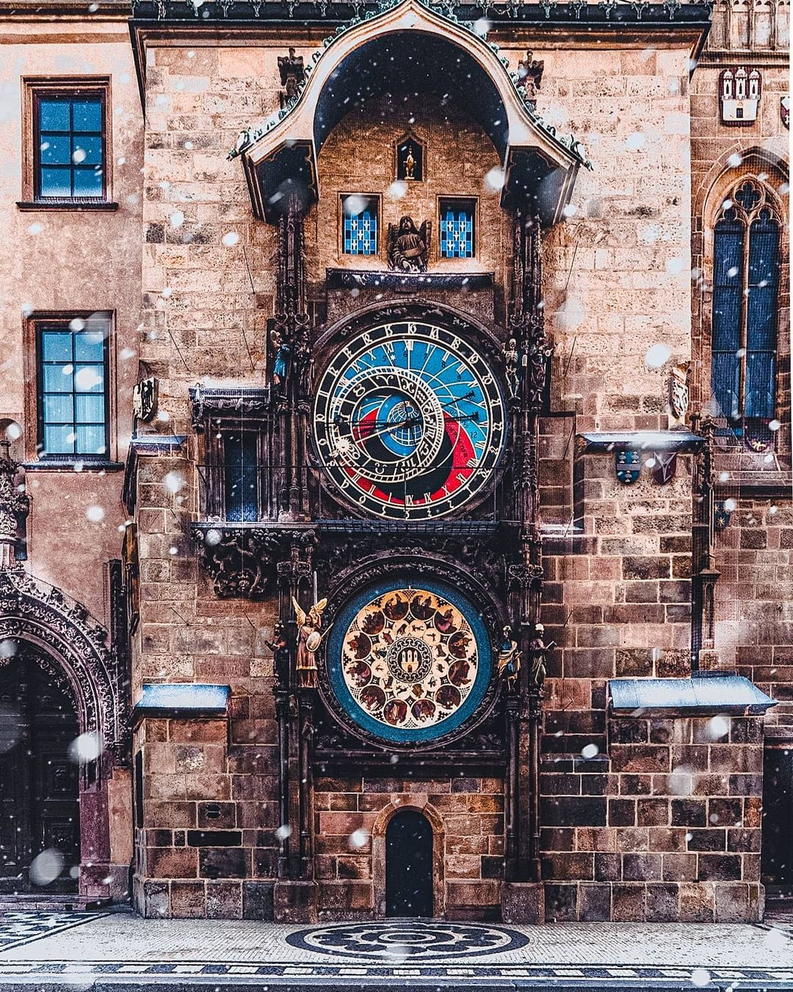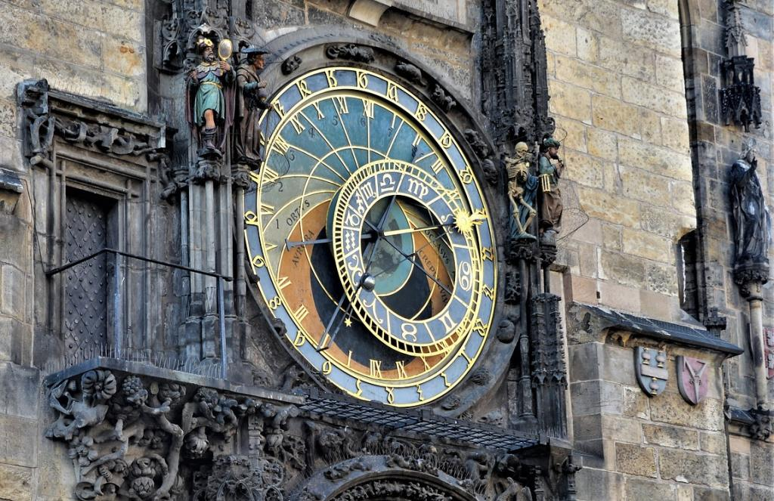

Moon Map and the Prague Clock
[UPDATE: 11/4/22]
FACT of the matter is we do have an Antarctic circle. It is not constantly fixed in the north and south poles of the globe model as we are taught though. The location of our ice wall changes every so many hundred or thousand years, and at a crawling rather than breakneck speed, freezing new land in its path while simultaneously melting its hind trails as it moves along the outer edges of our realm. Try to explain something like this to the normies. It can’t be done unless they are first willing to accept the reality of the flat earth. The Prague astronomical clock is key in understanding all of this, and so, I will attempt to show you how it works in accordance with the moon map.
Allegedly installed in the quote-unquote “medieval age,” 1412 to be exact, the Prague clock is located in the Czech Republic and, though not the first of its kind, is said to be the oldest surviving in the world. Impressive. It was built during the dark ages and people still struggle to understand it. Medieval as you know is codeword for the Millennial Kingdom. They all knew. The clock mechanism has three main components. The astronomical dial, representing the position of the Sun and Moon in the sky; statues of various saints as well as a notable skeleton who represents Death when striking the time; and a zodiac calendar dial representing the months.
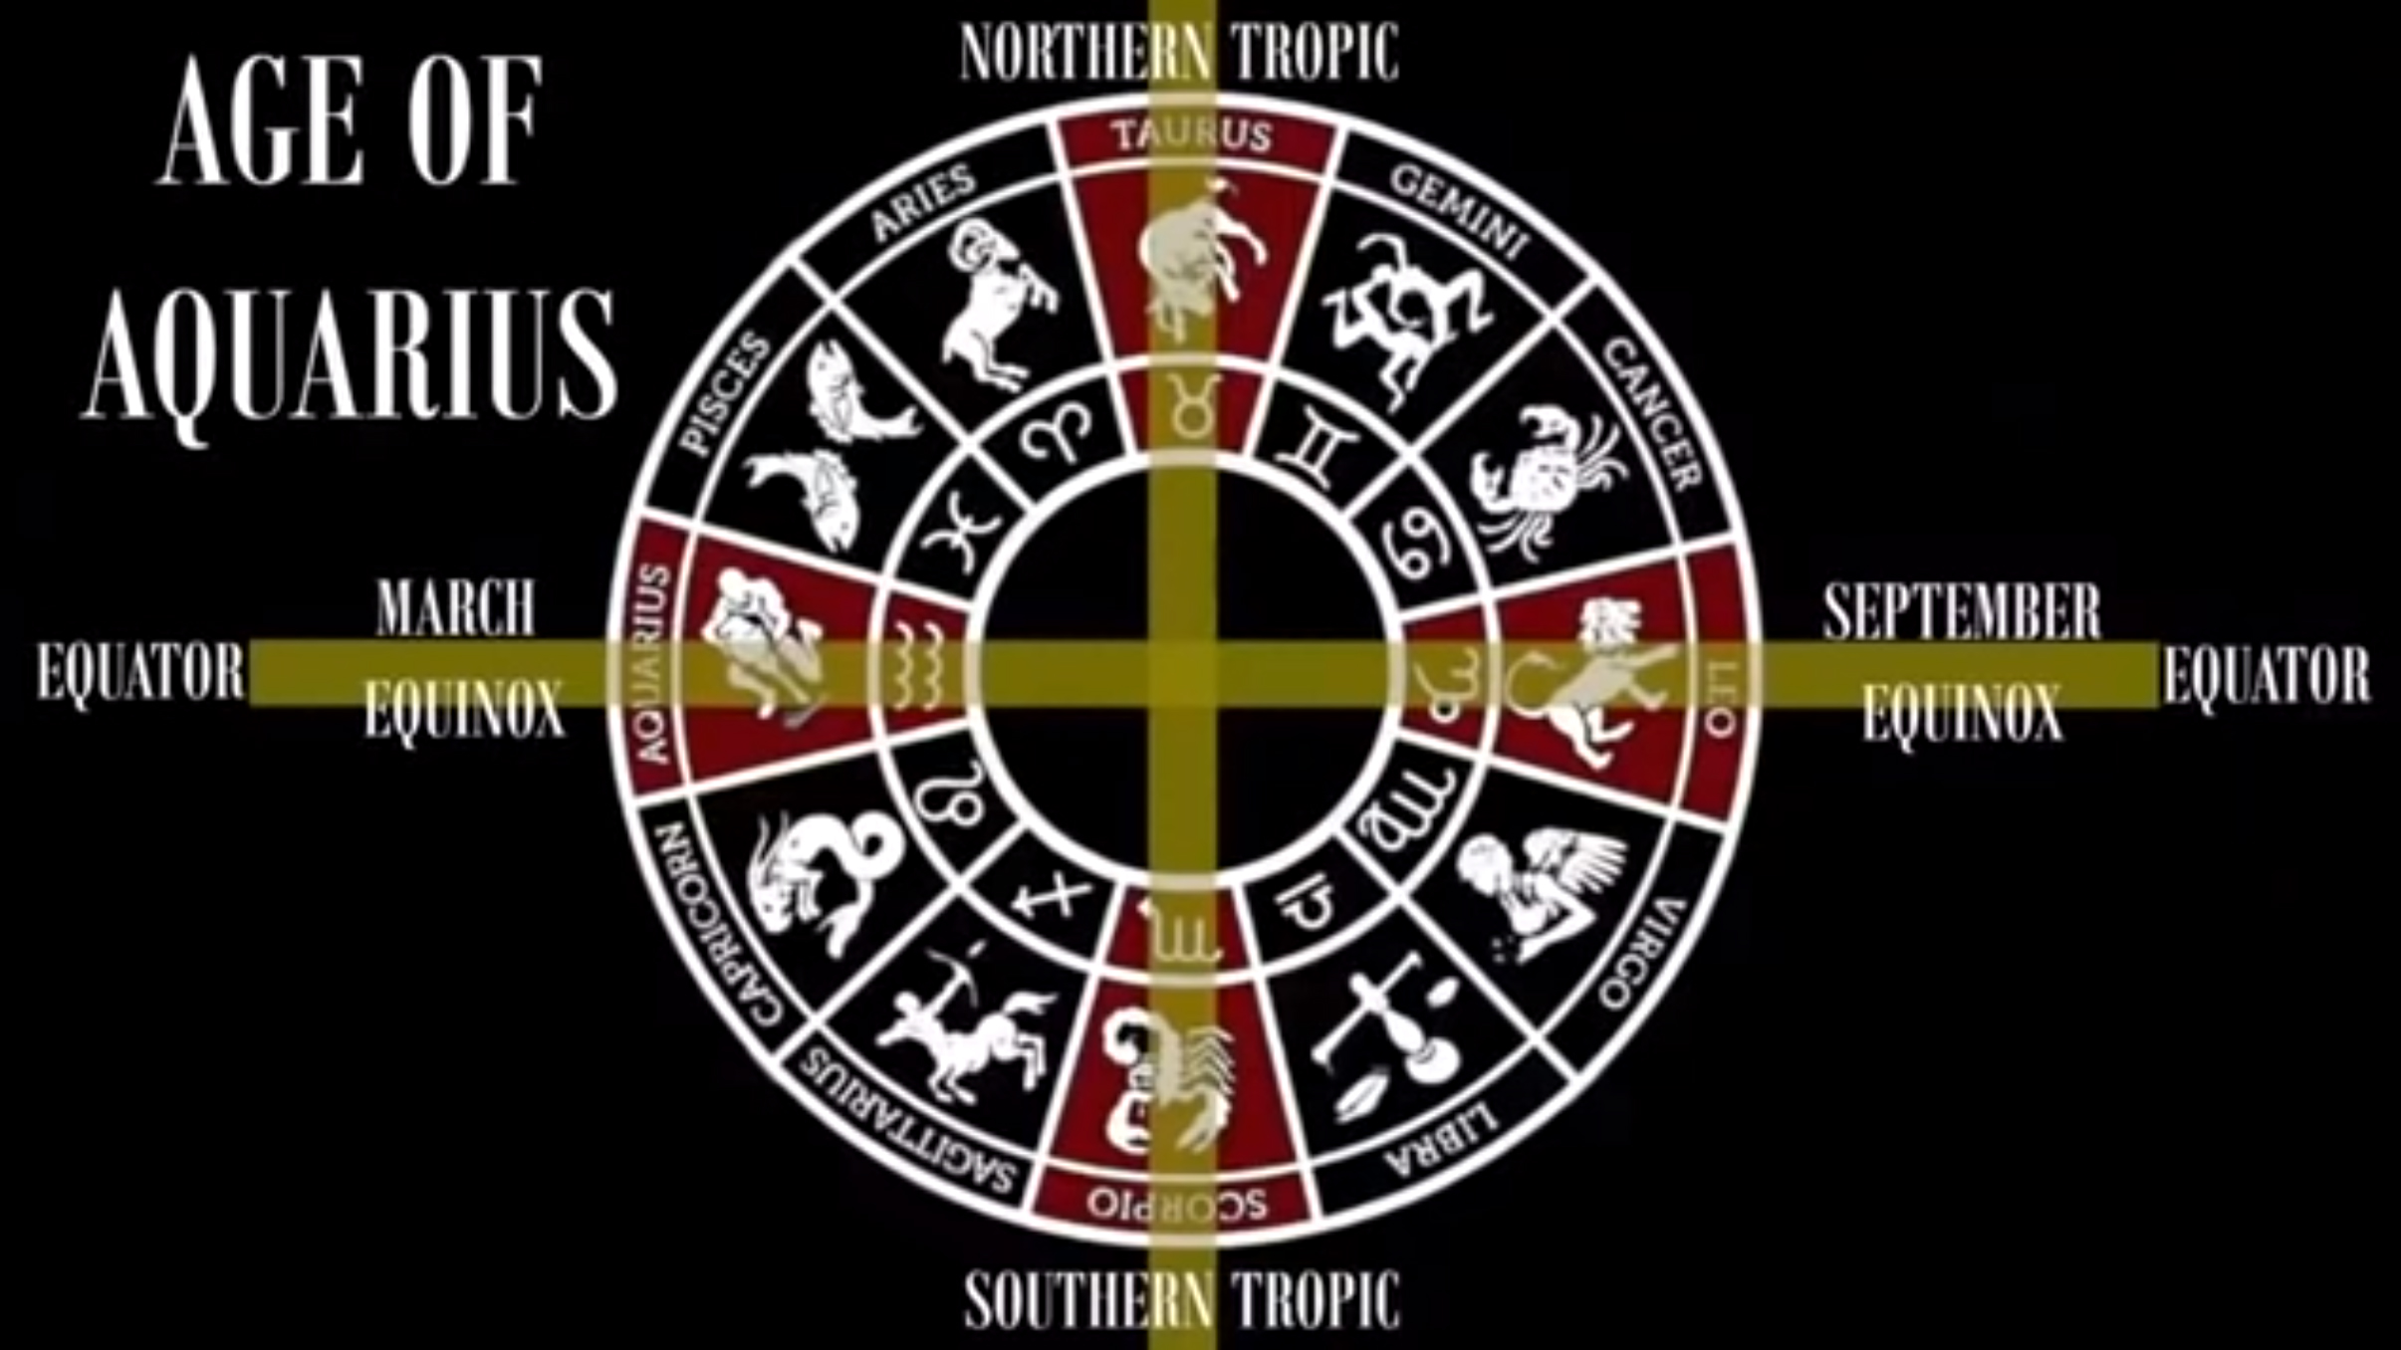
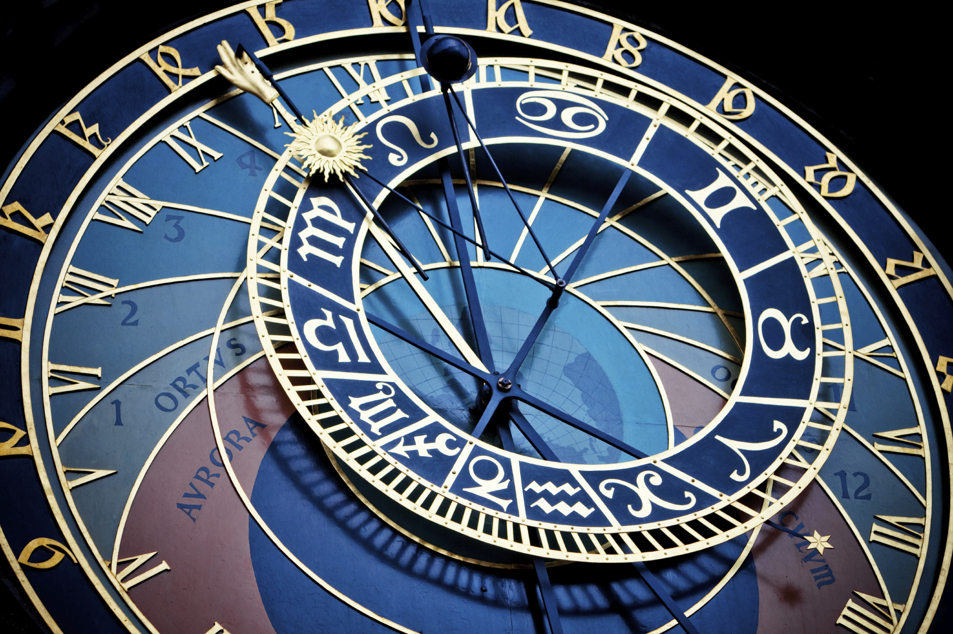
At the outer edges of the clockface, golden Schwabacher numerals on a rotating ring present Old Czech Time, with 24 indicating the precise time of sunset. Next, we see Roman Numerals displaying a repeated run of XII for morning and afternoon hours. The sun and the moon are accounted for on the ecliptic. Look at where their dials meet. They are fixed in place in the center of the clock, forming a cross. A Latin cross. The inner circle contained within that cross, what is known as an ecliptic dial, carousels around the entirety of the clockface. Each zodiac sign represents a month of the year, with the vertical lines measuring five days. This is important because the zodiac is the clockface in the sky above us.
Every year at the March equinox the location of the sun within the zodiac determines what age we’re currently inhabiting. There are of course 12 constellations of the zodiac if you need a refresher. It takes roughly 2,150 years for the sun to present itself among a new zodiacal constellation at the vernal equinox, with a precession that lasts 25,800 years in total. The difficulty is in determining precisely when one constellation boundary ends and another begins, but I am thinking it was designed that way so that the ages blend together. Well, it is generally agreed that the sun passed from the constellation Aries to the constellation Pisces with the advent of Ha’Mashiach or perhaps a century earlier. What is certainly true is that the sun has saluted us from Pisces throughout the span of Yahusha’s earthly life as well as the Millennial Kingdom, not forgetting the intervening years of the short season where we find ourselves now, and everybody is wanting to know when and if the sun has entered the age of Aquarius yet. I have seen any number of dates suggesting the starting date, 2012 being a popular contender. 2021 has also been declared. And still others have claimed it won’t be entered for another few hundred years yet.
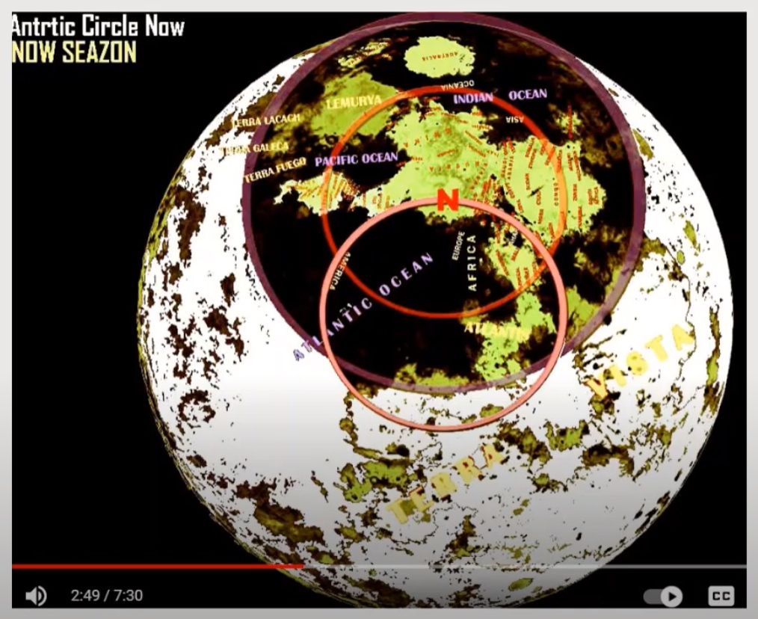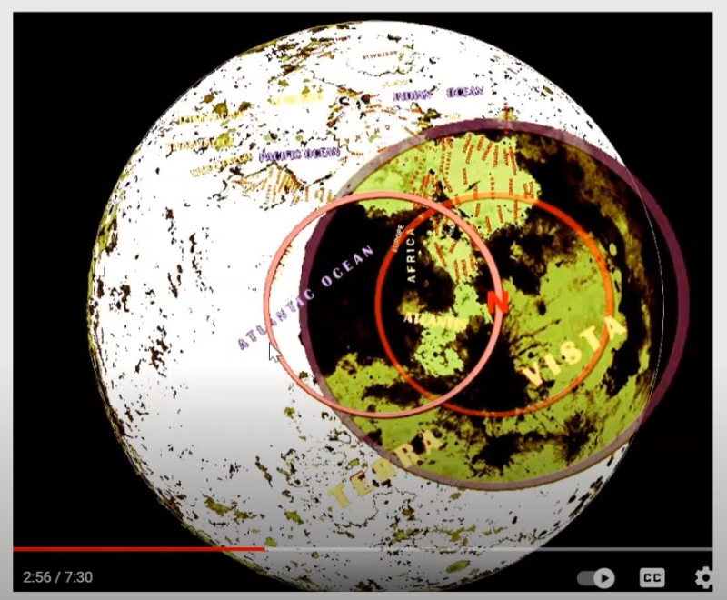
Take the ecliptic dial off the Prague clock, apply it to the moon map, and what do we see? A wheel within a wheel. For starters, everything pivots in accordance with the location of True-North, which in turn rotates around Polaris, the very center of our realm. The ring containing visible land masses represents the Arctic circle that I was reminding you of earlier. The circuit of the sun and the moon can be found within.
Everything beyond the ring is the easily recognizable crescent moon, a popular symbol all over the world. That happens to be where the ice age resides at any given time. At present, we find ourselves in the first picture, stage left. But in so many thousand years, perhaps in the age of Capricorn or Sagittarius, the circuit of the sun and the moon will have rotated around to the illustration on the right, burying most of our known realm in ice and darkness. Those who insist the kingdom of heaven is eternal and that we therefore cannot possibly be post Millennial are absolutely true on the first claim. The kingdom is eternal. It will never be broken. But that is not to say its people aren’t free to chase the warmer weather. My family hightails it to Florida every winter. Or in the case of our Controllers, the set-apart are free to pursue the light of Yahusha on the other end of the world. The kingdom still exists. Look out your window, why don’t you? Ironically, it may just be our current sun, with its endless Platonic allegories, which proves to be the outer darkness after all.
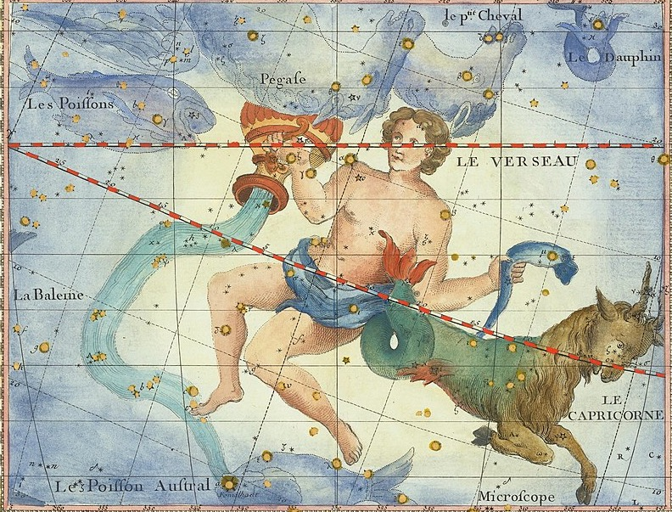
Again, it takes something like 26,000 years for the entire cycle to play out, apparently. That’s nearly four separate creation weeks. Three if there are centuries of chaos and void between each destruction and reset event, whereas only darkness and the howling wind remains a constant. It makes you wonder, if there truly are resets and new creation weeks every so many thousands of years while magnetic north rotates the heavenly carousel around the moon face, then how many earth-worn artifacts testify to the former inhabitants of our realm on the last go-around?
Also, how do you suppose our Controllers feel about this, knowing that their kingdom of dirt is destined to be discovered by a whole new regime of pimps and handlers in another 25,000 years or so? It’s not like they can keep continent hoping and migrating with the magnetic wheel if what I’m insinuating about the hidden wilderness is true. Seems to me that the weather would be an important topic, as it’s about to get butt cold around here.

